Documents released by a federal court provide new and disturbing details of Trump associates’ attempt to orchestrate a coup against a government they clearly did not understand. This is an unprecedented look at the players and their plots – from terrorism to false flags – that may inform the looming US military assault on Venezuela.
The man the government blames for it all, Jordan Goudreau, provided evidence to The Grayzone that:
This Substack is reader-supported. To receive new posts and support my work, consider becoming a free or paid subscriber.
- He signed a $221 million contract with Venezuela’s Juan Guaidó as the US schemed in public and in private to designate him the legitimate president of the country.
- High-ranking Trump officials including Elliot Abrams, John Bolton, the top CIA official in Latin America, and a top NSC advisor appeared to know about his invasion plot, and may have been involved in its planning.
- Trump associates formed a shady company to pursue profits in a post-Maduro Venezuela after a Guaidó associate urged them to “act now, get companies and get paid.”
- The CIA and an intelligence-linked propaganda firm called The Rendon Group carried out sabotage of critical Venezuelan infrastructure “for a decade or so.”
- A proposal delivered to VP Pence’s office included plans to conduct “false flag” operations in Venezuela, spread hepatitis within the country’s military, and fund the schemes through the “expropriation” of “drug product.”
- Roen Kraft, a wealthy intelligence-tied financier recruited to fund aspects of the operation, told the FBI that he concluded “if Venezuelans see something they will steal it,” accusing Guaidó’s pals of pocketing $200,000 in humanitarian aid money.
- Participants in the plot told the FBI they viewed the Venezuelan opposition as hopelessly corrupt after witnessing its leaders blow huge sums “on hookers, thousand dollar bottles of wine, and nail appointments for their girlfriends.”
On the morning of May 3, 2020, two small vessels powered by outboard motors prowled through the coastal waters of Venezuela’s La Guaria region. Unlike the fifteen speedboats recently sunk by the US Navy, they weren’t alleged to be carrying drugs. Instead, they held something far more alarming – former US special forces soldiers hoping to be received as liberators by the Venezuelan people.
Alongside the handful of Venezuelans they had trained in the Colombian jungle, former Green Berets Airan Berry and Luke Denman planned to set off a violent national insurgency which would culminate in the toppling and kidnapping of the President of Venezuela, Nicolas Maduro.
Hours later, the pair were videotaped on the docks of a fishing village, face-down and hogtied by the very Venezuelans they believed they were saving. Officially, the ill-fated coup d’etat was known as Operation Gideon. But it would come to be known popularly as the “Bay of Piglets,” a comical redux of the failed 1961 CIA-backed invasion of Cuba’s Bay of Pigs.
Eight Venezuelan exiles were killed amid the aborted 2020 incursion, and prison interviews with the two captured Americans soldiers were subsequently broadcast to TV audiences across Venezuela. In the footage, Berry and Denman made clear that authorization for the operation went all the way to the top of the US government, pointing directly to President Trump as chief executor of the mission.
Trump’s then Secretary of State, Mike Pompeo, denied any “direct” involvement by the US. In the years since, the US has sought to cast the plot as an unauthorized operation carried out by a rogue mercenary named Jordan Goudreau. The decorated former Green Beret, who’s since become the face of Operation Gideon, was arrested in 2024 and now faces 14 charges over the federal government’s allegation that he conspired to smuggle weapons through Colombia in the runup to the failed plot. The charges carry a maximum combined sentence of 10 years.
In interviews with The Grayzone, however, Goudreau insisted he was personally recruited to lead a coup against Venezuela’s government by the head of Donald Trump’s security team, Keith Schiller, and that the operation proceeded with the full knowledge and support of the US government.
Now, Goudreau’s legal team has gained access to previously unseen evidence about the figures who he says orchestrated the planned coup. The Grayzone is among the first publications to have reviewed the material, which includes FBI interviews with participants in the plot which demonstrate foreknowledge by top Trump associates, leaders of the government of Colombia, CIA officers and assets, and officials working directly under Vice President Mike Pence and Trump. The documents contain strong suggestions that at various stages the US government monitored and supported the operation, which was sponsored by American financiers close to Trump, as well as Venezuelan opposition leaders financed by Washington.
Behind the cloak of high-minded objectives like “democracy promotion” and holding “bad actors” to account, the Beltway operatives and spooks who allegedly recruited Goudreau to lead them to Caracas were driven by little more than greed. Hungry for a cut of Venezuela’s vast oil and mineral wealth, and eager for lucrative contracts on the day after Maduro’s departure, the white collar coup plotters embarked on a quest for plunder that ended in infamy.
The files reviewed by The Grayzone also include surreptitiously recorded discussions, emails and elaborate plans for coups and terrorist attacks concocted by influential Venezuelan opposition figures. Taken together, they paint a deeply unflattering portrait of the political circle which the US has trained and sponsored over the course of two decades. Among the allegations most frequently leveled by those involved in Operation Gideon was that top opposition figures were not only clownish degenerates, but prone to stealing from their patrons in Washington.
Those exposed for profligate corruption in the Operation Gideon files are poised to take power if the US military show of force ordered by Trump this October winds up toppling Venezuela’s government. They include two opposition leaders derided by a US financier of the operation as “Beavis and Butt-head,” as well as their former boss, Leopoldo Lopez, and his understudy, Juan Guaidó – who’s described in one FBI file as a potential recipient of funding from unnamed “drug dealers.”
However, the only figure to have faced criminal penalties for Operation Gideon in the US is the former Green Beret who executed it. Facing years of hard time in a federal penitentiary, Goudreau has skipped bail and disappeared. Before absconding, he participated in several interviews with The Grayzone, and provided us with an “intel brief” arguing that he would have never been in a position to lead a private army into Venezuela without the knowledge and blessing of the Trump White House.
‘We Have Many Options For Venezuela’
Once seen as a solid US ally and reliable Cold War intelligence collaborator, Venezuela’s relationship with Washington began to fray when it elected the populist Hugo Chavez in 1998. The charismatic army officer, who came to prominence upon leading an unsuccessful revolt against a repressive and unpopular neoliberal government in 1992, plunged headfirst into an ambitious plan to fund mass anti-poverty campaigns by nationalizing Venezuela’s oil fields.
In the following decade, Chavez’s initiative increased Venezuelan standards of living and oil production, reducing extreme poverty by two-thirds as revenue from oil exports quadrupled. But it was less popular in Washington, which responded in 2002 by orchestrating a coup d’etat that deposed the president for nearly 48 hours before spontaneous mass demonstrations and loyal factions of the military restored him to power.
After Chavez’s untimely death in March 2013, his preferred successor and Foreign Minister, Nicolas Maduro, was elected months later. Within a year, then-President Barack Obama enacted sweeping sanctions against Venezuela, leveling claims of human rights abuses to justify targeting the country’s oil sector, and setting the stage for a series of violent regime change operations.
As tensions rose between the elected Venezuelan government and its US-backed antagonists, fueling violent opposition-led street riots that paralyzed the country’s economy, Maduro ordered the dissolution of Venezuela’s opposition-controlled National Assembly and called for new elections in 2017. In response, Trump escalated further, threatening to invade the country if Maduro refused to step down.
“We have many options for Venezuela, including a possible military option, if necessary,” Trump told reporters during a press briefing that August.
Maduro was subsequently declared the winner of a snap 2018 presidential election, which the Trump administration condemned as illegitimate. The next year, the Trump administration declared the previously obscure National Assembly leader Juan Guaidó as Venezuela’s president, citing a little-known clause of the country’s constitution which it insisted invalidated Maduro’s hold on power.
Washington’s recognition of Guaidó enabled the theft of Venezuela’s gold reserves from the Bank of England, as well as the expropriation of its most valuable asset, Citgo, the international arm of its state-owned PDVSA oil company. By wresting billions of dollars of wealth from the elected government in Caracas, the US government not only fueled poverty and mass migration, it invited corruption from the Venezuelan opposition figures funded from the stolen assets.
However, like past plots to depose Venezuela’s socialist leadership, Guaidó’s pretend presidency would peter out in embarrassing fashion. Its demise began with a failed February 2019 operation to force huge shipments of USAID-supplied goods across the Venezuelan-Colombian border.
The death of Venezuela Aid Live
The plan aimed to breach the country’s borders under humanitarian cover, ramming caravans of trucks into the country, then accusing Maduro of cruelly rejecting aid for a supposedly desperate population if his security forces obstructed the hostile intervention. If the Venezuelan government failed to prevent the aid caravans from entering the interior, its loss of control would inspire a wider rebellion.
But the humanitarian propaganda stunt ended in almost immediate ignominy when its initial wave failed to breach a phalanx of border guards, and bands of frustrated Venezuelan opposition hooligans torched the aid, while making off with the rest. An attempt to blame the burning of millions of dollars worth of aid on Maduro’s forces failed as well when The Grayzone’s Max Blumenthal and numerous local reporters exposed the opposition’s responsibility.
A slapdash Live Aid concert held simultaneously in the border town of Cúcuta, Colombia sponsored by neoliberal British oligarch Richard Branson was no less successful, with much of its proceeds looted by Venezuelan opposition figures. Polling found less than 1% of concertgoers stuck around to help after the star-studded concert.
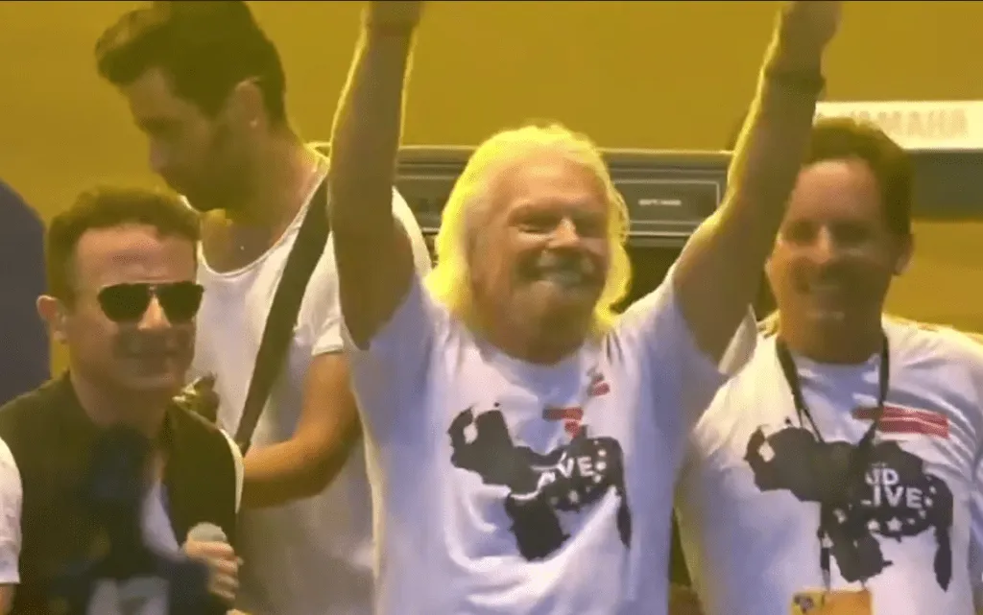

Meanwhile, opposition-aligned media revealed that Guaidó’s cronies had embezzled massive sums of money that had been promised to Venezuelan soldiers who defected to Colombia and joined the anti-Maduro rebellion. In the end, the turncoat soldiers were left penniless in the border town of Cúcuta while top Guaidó henchmen blew their cut of the aid money on prostitutes and lavish hotels. Two of those would-be putschists, Freddy Superlano and his cousin, Carlos José Salinas, were found unconscious in their hotel room after being drugged and robbed by two prostitutes they had apparently paid with money intended for destitute Venezuelans.
For his part, Guaidó was photographed in the days before the aid stunt on the Colombian side of the border with top leaders of the notorious Los Rastrojos drug cartel, who reportedly smuggled him into Venezuela.

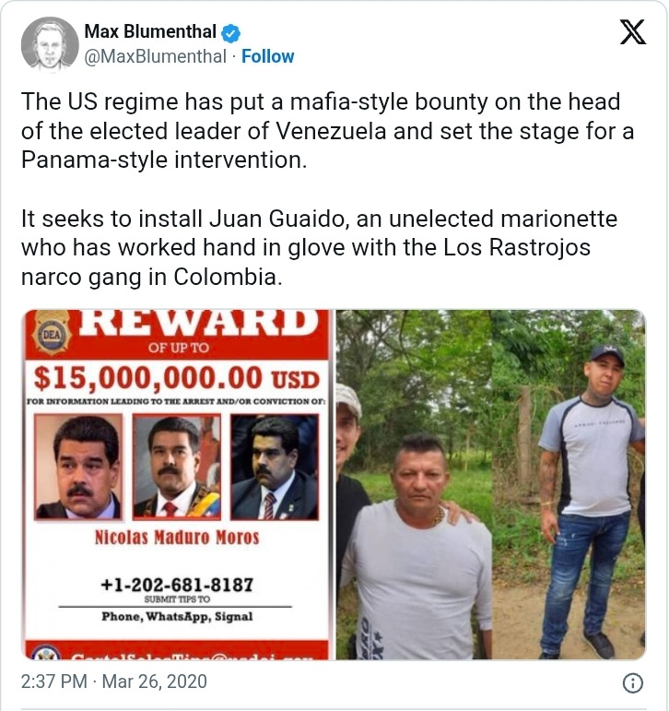

Following the failure of the humanitarian intervention, and with options for toppling Maduro dwindling, the Trump administration took an extraordinary measure clearly designed to incentivize private coup plots. On March 26, 2019, Trump’s Department of Justice offered a $15 million reward for information leading to Maduro’s capture.
At the time, Goudreau was exploring an invasion of Venezuela to gather the bounty and make himself a mercenary superstar. Following tours of duty in Iraq and Afghanistan, where he earned distinction from fellow special forces operators for his human intelligence skills, Goudreau set out for work in the private security field. He worked at least one Trump campaign rally, with a photo posted on his security firm’s Instagram account showing him among the president’s security detail in Charlotte, NC in 2018. A year later, he was among the team that provided security at the ill-fated Live Aid concert on the Colombian-Venezuelan border a month before.
It was around this time that Goudreau said he was introduced to Keith Schiller, a longtime head of security for Donald Trump and point-man on several Trump family foreign ventures.
In early 2019, Schiller was one of a handful of Trump associates, Beltway lawyers, and resource-hungry industrialists who banded together to seek out lucrative contracts in a fantasy post-Maduro Venezuela. Operating under the name “Global Governments,” the shadowy group would quickly come to leave its mark on Venezuela — though not in the way its founders intended.

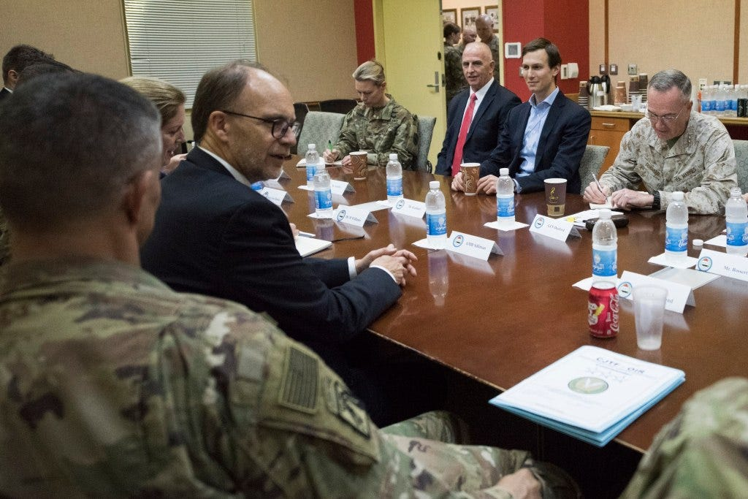
Keith Schiller seated on the left of Jared Kushner during a 2017 trip to Iraq

Monetizing regime change
In an interview with The Grayzone’s Max Blumenthal, Goudreau said the Global Governments team had a simple set of motives: “They wanted business contracts. They wanted a way to monetize the aftermath of a Maduro-free Venezuela.”
Besides Schiller, those listed in internal documents as members of “The Team” include:
- Roen Kraft, a senior adviser for logistics and transportation for the company whose first name is publicly unlisted, but appears to be Timothy. According to a Global Governments associate, “Kraft dealt in energy, oil, gas, mining, was experienced and capable in international business and was a logical fit for these roles. Kraft also had dealt with these things in Nigeria which was a hostile country to work in.” Kraft later told the FBI he was positioned to provide funding for subsequent humanitarian interventions in Venezuela, and recoup his losses in the form of oil profits and contracts on the day after Maduro’s ouster. It is unclear if Kraft is an heir to the Kraft cheese fortune, as has been reported by some outlets.
- Nestor Sainz, a former State Department desk officer and DC-based operative, took on a role in Global Governments to bridge his Beltway contacts with his ties to the Venezuelan opposition. FBI interviews of Global Governments associates indicate Sainz cultivated ties to several close associates of the top power broker of the US government-backed Venezuelan opposition, Leopoldo López.
- Gary Compton, the “counsel and lobbyist to energy magnate T. Boone Pickens for over twenty years” was described as an oil and energy expert by his Global Governments associates. He was listed as a former partner at the law firm of Travis Lucas, who was frequently present during company meetings related to Venezuela.
- German Chica, a Venezuelan opposition figure who appeared occasionally in Global Government meetings as a liaison to anti-Maduro forces. Chica was a governor of the Luna Foundation, which was supposedly dedicated to women’s rights, and listed Global Governments as a partner.
- Andrew Davis, chairman of the Catalan America Council, which lobbied for Catalan independence from Spain.
- Travis Lucas was not listed as a former member of the Global Governments team, however he acted as Schiller’s Washington-based lawyer. Having legally represented then-Vice President Mike Pence and then-Secretary of State and former CIA Director Mike Pompeo, Lucas offered the company a potential line to the Trump administration’s upper echelon.

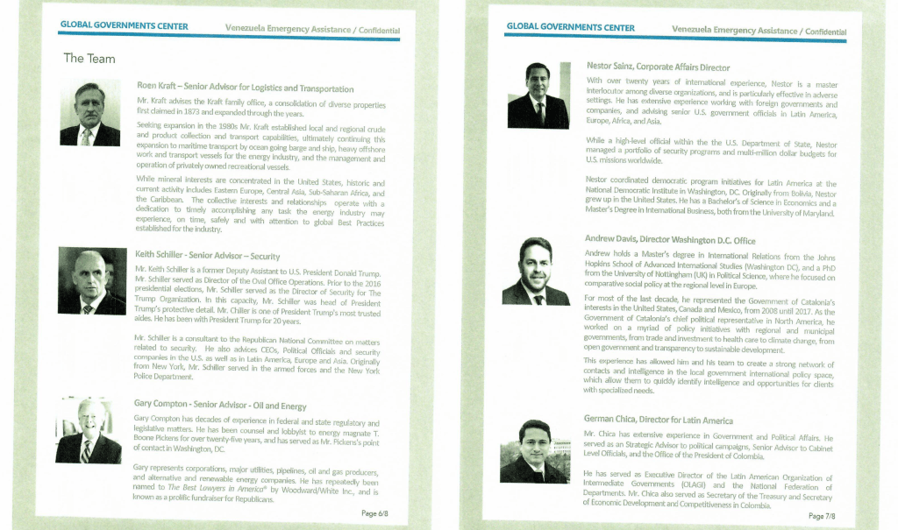

A Global Governments prospectus contains biographies of its high-profile associates.
Global Governments established its first and only client early in 2019 when Sainz reached out to Dick Morris, the celebrity Republican consultant, to pitch the company’s plans for raking in lucrative contracts after the toppling of Maduro. According to Sainz, Morris contacted his brother-in-law, Chris Larsen, who headed an international construction firm called Halmar, and expressed strong interest in the project.
In early February 2019, Larsen arrived at Global Governments’ office in DC to discuss the path forward with Kraft, Sainz and German Chica. Dick Morris was also on hand for the meeting. Apparently Larsen liked what he heard, because according to Sainz, he became the first and only client Global Governments signed for its post-Maduro gold rush.
The Jersey construction baron sent an initial retainer fee of $16,000 to Global Governments, pledging six more over the next six months. After shelling out close to $100,000, however, Larsen bailed on the project, as it seemed to be going nowhere fast.
According to an FBI document, “Sainz said it had been several months and they had not done anything for Larsen and understood why he wanted to leave. When the check arrived from Larsen it was cashed and divided between the Global Governments team.”
Though Global Governments struggled to get off the ground, Sainz told the FBI that it was clear the firm was preparing a military-style operation in Venezuela – a perception which Goudreau confirms was widely shared.
“The first meeting we had, all of us together with Global Governments, everybody knew I was going to do a military coup,” Goudreau said.

‘Act now, get companies, and get paid’
“It all started at a University Club Washington meeting on 19 March 2019.”
That’s how Lester Toledo, the self-styled aid director for Juan Guaidó, described his first meeting with Trump associates and Global Governments principals at the University Club, a posh member’s only club in downtown Washington DC. Together, the coup-curious crew brainstormed on a way forward after Guaidó’s bungled humanitarian aid stunt a month prior.
On hand for the initial meet-and-greet were Sainz, Schiller, Lucas, Kraft, and representatives of the Danish shipping company Maersk, who were expected to handle logistics for future aid operations.
“No military action was discussed at this meeting,” Toledo claimed to the FBI.
Two weeks later, Toledo said he received a text from Schiller seeking to introduce Goudreau as the potential leader of a team providing security for aid shipments into Venezuela. In an interview with the FBI two years later, Schiller echoed Toledo’s account, insisting Goudreau was never supposed to lead a private military invasion.
Next, Goudreau and Schiller headed to Boca Raton, Florida in early April to discuss their emerging plans with Toledo. During that discussion, Schiller wondered how supposedly humanitarian aid could be secured if Maduro were toppled by force. “There might be a disaster,” the Trump security man warned.
Next, in an April 16, 2019 email, Schiller organized a call to introduce Goudreau to Global Governments’ corporate affairs director.
As Global Governments grew closer to Guaidó’s inner circle, one of its advisors, a former State Department official named Nestor Sainz, learned of a decisive plan by the Venezuelan opposition to incite a military uprising against Maduro and take power by force.
During a wide-ranging interview with the FBI, Sainz said he was informed of the military coup at least a year before its execution, having been tipped off by a close confidante of Guaidó named Pedro Paul Betancourt. According to Sainz, the Guaidó associate marketed the coming putsch as an opportunity for potential US supporters to “act now, get companies, and get paid.”
In the FBI interview, Sainz insisted that he merely sought to help introduce energy companies to oil-rich Venezuela, as well as construction firms which could rebuild the country’s damaged infrastructure.
Global Governments affiliates echoed this line, claiming they were solely interested in humanitarian efforts and business opportunities under a pro-US, market-friendly Venezuelan government. However, newly-unsealed documents and witness testimony show they frequently discussed military action against Maduro during their meetings.
On April 13, 2019, Kraft fired off an email to Sainz, Schiller, Lucas, and other Global Governments affiliates, in which he declared, “There are now few, if any, that believe [Venezuela] will have a change of government without military action of some degree. Doors are closing around Maduro and actions are underway to assure his fall and removal.”
Kraft stated that the Venezuelan opposition had requested a proposal from him to pave the way for this “military action” by staging supplies and assets around the country’s borders: “The ask from Guaido is for a proposal with time to mobilize, prior work in this regard, followed by draft form of master services… I believe Curacao is the best location to stage from, as VE now has 17 bases on the frontier border with Columbia [sic]. With Navy disabled, it is a safer approach from Curacao and… we can divert to Columbia [sic] to land with ease.”
Kraft seemed to suggest obtaining funding from the Inter-American Development Bank (IADB), though he noted it would only pay for mercenaries if they were falsely classified as health and safety personnel. “Please note IADB will not pay or approve payment for warfighters or security. They will need to be booked and invoiced as something such as HSE personnel,” the financier wrote.

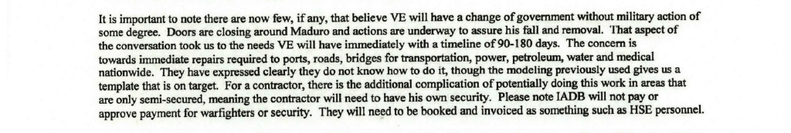

The coming coup plot hinged on mass defections by Venezuelan military leaders, and was to have culminated in the seizure of Miraflores Palace.
However, when Guaidó executed the plan on April 30, 2019, it resulted in an even greater political catastrophe for the Venezuelan opposition than the botched aid stunt months prior. The military stuck solidly with Maduro, leaving Guaidó’s men isolated and outgunned in the streets of Caracas. All were killed or arrested.
As the military mopped up the remains of the operation, a photo circulated throughout international media showing the presidential wannabe looking forlorn, abandoned by his supporters and standing isolated on an overpass in Caracas alongside his mentor, Leopoldo López.

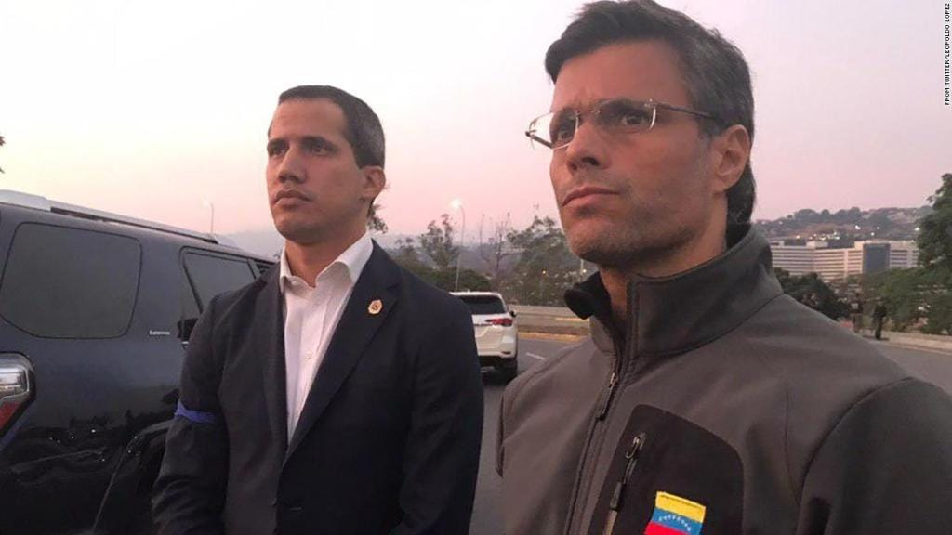

The failure proved to be Guaidó’s coup de grace, prompting a series of bizarre political stunts and public humiliations before his career in Venezuela ultimately fizzled out. He absconded to Miami in 2021, where he now holds a symbolic professorship at Florida International University’s Adam Smith Center for Economic Freedom – a position specially reserved for fellow right-wing Latin American political wash-ups.
Hours after the failed April 30 uprising, then-Secretary of State Mike Pompeo attempted to restore the morale of would-be coup plotters, declaring in an interview with the Fox Business network that Trump remained open to military action against the Maduro government: “The president has been crystal clear and incredibly consistent: military action is possible. If that’s what’s required, that’s what the United States will do.”
At this point, Goudreau moved to center stage as Global Governments sought alternative means of deposing the Venezuelan President. For help on the ground, they turned to a pair Venezuelan opposition figures who were said to be CIA assets.

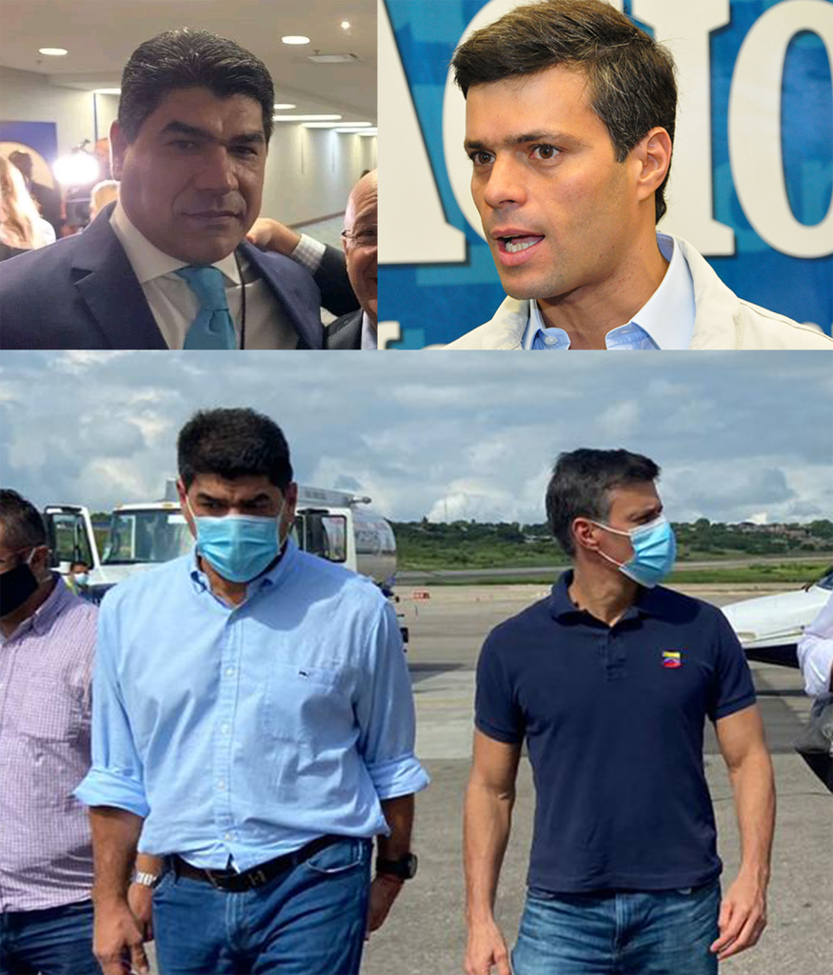
Jorge Betancourt (left) is seen walking alongside his longtime boss Leopoldo López (right) after touching down in Cúcuta, Colombia in 2020. They had just exited a plane owned by a Florida-based company that had previously sold a plane to a Colombian who was busted in Honduras for transporting 500 kilograms of cocaine.

Introducing “Beavis and Butt-head” – and their “CIA handler”
On May 3, Nestor Sainz asked Goudreau to introduce himself and his private security company, Florida-based Silvercorp USA, to the rest of the Global Governments team.
In an email to Sainz and Schiller two days later, Goudreau put forward his supposedly “peaceful options” for regime change, which entailed neither “foreign military involvement nor contractor participation.” He contrasted his own plans with “the US military option for power conversion.”
But having “personally used [it] in parts of the Middle East,” Goudreau acknowledged that American military intervention in Venezuela “has the potential of costing many civilian lives” and “may also throw the country into civil war.”

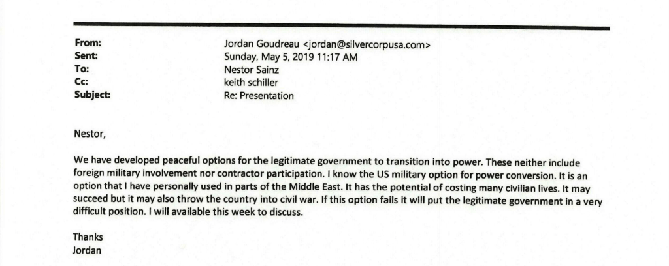

By this point, Goudreau had become a recurring presence in discussions with Global Governments and the organization’s contacts in Venezuelan opposition circles. Accounts of the interactions differ, but the details Sainz described to the FBI largely align with Goudreau’s statements.
Through Sainz, Goudreau and Global Governments were introduced to a pair of Venezuelan opposition activists with close ties to the US government and purported links to the CIA. They were Lester Toledo, the aid director to Guaidó, and Jorge Betancourt Silva, an operative Toledo described to the FBI as “the right hand man” of Guaidó’s mentor, Leopoldo López.
Goudreau characterized Betancourt as a kind of ghost, telling The Grayzone, “you can’t find his name in the news anywhere. It’s well protected.” And indeed, it is nearly impossible to gather information or even a mere mention of Betancourt through a simple Google search. However, a smattering of Venezuelan blogs and FBI interviews reveal him as a former bodyguard for Leopoldo López with a penchant for unsavory behavior.
Raised in the small mountain town of Caripe, Betancourt was likely introduced to the opposition faction by Carlos Vecchio, a Venezuelan lawyer from the same town who represented ExxonMobil before being appointed as Guaidó’s ‘ambassador’ in the US. Though they do not appear to be blood relatives, multiple social media posts by Leopoldo López refer to Betancourt as his “brother.” Photos taken during a 2020 trip by López to Cúcuta, Colombia show Betancourt acting as his personal bodyguard.
The rest of his family is similarly involved in Venezuelan opposition politics. When the US-backed group pursued negotiations with the Venezuelan government in Mexico in 2021, it was represented by Betancourt’s sister-in-law, Claudia Nikken.
Toledo helped López found the US government-funded Voluntad Popular party, which launched a violent color revolution in 2014, erecting armed barricades known as guarimbas throughout the country. For his part, Toledo led opposition shock troops in the region of Zulia, where he had served as a legislator. When the Venezuelan government sought to arrest him for his role in the chaos, he fled to Spain, then relocated to South Florida to organize further destabilization attempts with Washington’s assistance.
In February 2019, Toledo traveled to the Colombian city of Cúcuta to represent Guaidó during the ill-fated ‘humanitarian aid concert.’ In addition to his work with the Venezuelan opposition, Toledo has served since 2019 as advisor to El Salvadorean President Nayib Bukele, the self-described “world’s coolest dictator” who has provided the Trump administration with space in his notorious CECOT Supermax prison to jail – and viciously abuse – deported Venezuelan migrants.

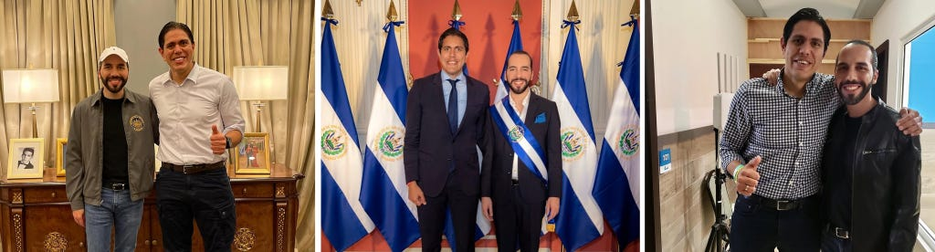

Photos posted on Toledo’s Instagram profile show him arm-in-arm with El Salvador’s iron-fisted ruler.
In 2024, Toledo began assisting Colombian presidential contender Uribe Turbay with what right-wing Latin America outlet Infobae described as an effort to replace Bogota’s current left-wing government with one “that is allied with the Venezuelan opposition and facilitates Nicolás Maduro’s departure from power” in 2026.
Colombia’s left-wing president, Gustavo Petro, is now at the center of Trump’s crosshairs, the subject of US sanctions and an escalating stream of invective from the US president.
But in his August 2020 FBI interview, Toledo styled himself as a humble “humanitarian aid director, while distancing himself from military-style plots against the government of Venezuela.
Sainz, however, painted a decidedly different portrait of the pair, telling the FBI that Toledo and Betancourt’s interests went far beyond humanitarian work. The former State Department official declared to federal investigators that the two Venezuelans were also directly involved in orchestrating wide-scale power outages, social strife, and a military coup against Maduro.
Sainz told the FBI that it was during a May 11, 2019, meeting at a WeWork office in Miami when he realized that the Venezuelan opposition members “weren’t just interested in humanitarian aid but also in overthrowing Maduro.” In Sainz’s retelling, participants – including Kraft, Schiller, Goudreau, Bonaventura, Betancourt, and others – were instructed to leave their cell phones outside of the room.
Upon being informed that Betancourt and Toledo “were organizing blackouts, civil unrest, and a military operation to overthrow Maduro” from an office in Colombia, “Goudreau raised his hand and said he could help them with that.” Sainz characterized this as the moment he realized Betancourt and Toledo “were involved in destabilization activities in Venezuela.”
During this meeting, Sainz said, Betancourt claimed to have contacts in the CIA. One of those contacts was likely Juan Cruz, a longtime intelligence operator who Goudreau described as Toledo and Betancourt’s “handler.” In 2017, Cruz was revealed by Univision to have served as the CIA’s station chief in Colombia before becoming head of the agency’s Latin American division.

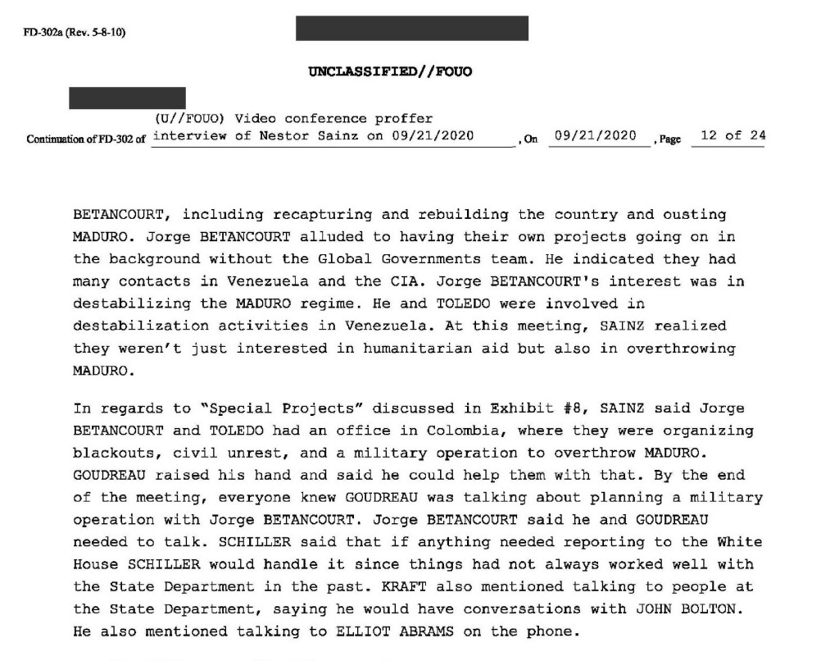

The pair of Venezuelan opposition operatives first linked up with the Global Government’s team during the University Club gathering in Washington DC in March 2019. And it was there that they first began their pitch to Kraft, the moneyman, to finance their operation to the tune of hundreds of millions of dollars.
The multi-millionaire’s account of his interactions with Toledo and Betancourt was decidedly unflattering. He was so eager to share it with the FBI, in fact, that he rejected his lawyer’s advice not to speak to federal law enforcement.
“Kraft said he referred to Jorge and Toledo as Beavis and Butt-head,” and “described them as being like children, with no class, grace or intellect,” the FBI noted. Kraft reportedly said that he “didn’t know why they showed up asking for hundreds of millions of dollars with no plan” but that they were “sent by Guaidó and were registered as Venezuelan representatives of the new government.”
The two men reportedly told Kraft they could transport shipping containers to Venezuela, but at nearly four times the cost he anticipated. “Kraft didn’t think the cost made sense and assumed they were skimming money off the top,” the FBI file states.
This characterization was corroborated by Goudreau, who told Kraft he was swindled out of nearly $30,000 by the pair, which squandered the money on luxury hotels, expensive alcohol, and prostitutes.
When “Goudreau called Kraft to tell Kraft that Toledo and Jorge ran up his credit card,” the FBI interview states, “Goudreau said they were spending money on hookers, thousand dollar bottles of wine, and nail appointments for their girlfriends.”
In Kraft’s retelling, he never wanted to participate in military actions, viewing Global Governments’ role as merely protecting shipments of humanitarian aid. The FBI interview notes state, “Kraft was told that if he could get resources to the people of Venezuela when the opposition entered, Kraft would be the prime contractor in Venezuela.”
Yet if he’d come to the country to extract wealth, he would first have to contend with the local knaves who provided his direct line to the would-be ruler of a post-Maduro Venezuela. From the very beginning, the FBI wrote, “Kraft had concerns about the Venezuelan culture” – specifically, “he said that if Venezuelans see something they will steal it.”
To illustrate his point, Kraft pointed to an unnamed husband-and-wife team whom he said had pocketed about $200,000 from the Richard Branson-sponsored humanitarian aid concert in Cúcuta, Colombia back in February 2019.

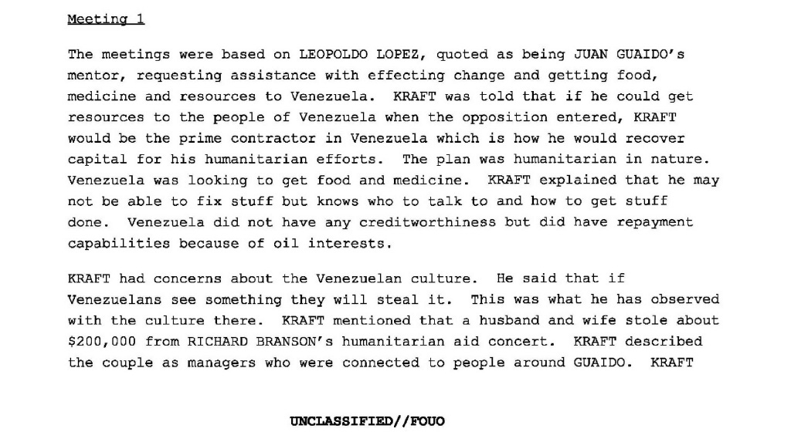

Bioterror, false flag, and PSYOP proposals pour in as the lights go out
As he escalated his military show of force against Venezuela in October 2025, President Donald Trump announced that he had authorized the CIA to conduct “lethal” activities inside Venezuela.
However, after working closely with the US-backed Venezuelan opposition for an extended period, Goudreau learned that US intelligence had been sabotaging Venezuelan infrastructure for years. He now argues that Maduro was correct to blame his opponents “any time the lights go out in Venezuela.”
Goudreau singled out a shadowy PR firm named The Rendon Group as a key CIA cutout for interfering in Venezuela. Founded by a former Democratic Party operative named John Rendon, the organization is best known for taking millions of dollars from the CIA in the 1990s to “create the conditions for the removal of [Saddam] Hussein from power.” In a 2004 profile in Rolling Stone, Rendon bragged to journalist James Bamford that “going all the way back to Panama, we’ve been involved in every war” but Somalia.
The Rendon Group “had been doing infrastructure attacks, or helping to facilitate attacks on infrastructure in Venezuela, for a decade or so,” Goudreau told The Grayzone. “These are all TS/SCI [Top Secret/Sensitive Compartmented Information] projects that the CIA oversees through these private companies.”
According to Bamford, Pentagon documents revealed The Rendon Group was authorized “to research and analyze information classified up to Top Secret/SCI/SI/TK/G/HCS” – an “extraordinary” combination of acronyms which “indicate that Rendon enjoys access to the most secret information from all three forms of intelligence collection: eavesdropping, imaging satellites and human spies.”
Goudreau confirmed the CIA’s longstanding sabotage campaign extended to Venezuela’s oil production sector as well. He pointed to a deadly 2012 explosion at the country’s biggest refinery which left nearly 50 Venezuelans dead.
It was “a major attack, and it killed many Venezuelans,” Goudreau stated. “This attack was carried out by US intelligence in collaboration with saboteurs from the Venezuelan opposition.”
Also among the discovery materials provided to Goudreau was an email sent by a representative of an organization calling itself Virtual Democracy, with an attachment describing proposals to create “conditions of ungovernability” in Venezuela in order to overthrow the Maduro government.
The email was sent on December 8, 2019 to Drew Horn, a top aide to Vice President Mike Pence, by a former Venezuelan anti-narcotics chief named Johan Obdola. Though bearing his name and signature, the proposal was presented as the handiwork of a group of six people including retired Rear Admiral Molina Tamayo, the highest-ranking military officer involved in the 2002 coup against Chavez. The document’s header shows the pitch was addressed directly to Pence.
Composed in non-native English and filled with grammatical errors, the document contained a collection of proposals for terrorist attacks across Venezuela, including “false flag” operations, the spreading of “Hepatitis (A, B and C), influenza, measles and piglet” in the locker rooms of Caracas country clubs frequented by government officials, as well as funding a planned insurgency by expropriating “drug product.”

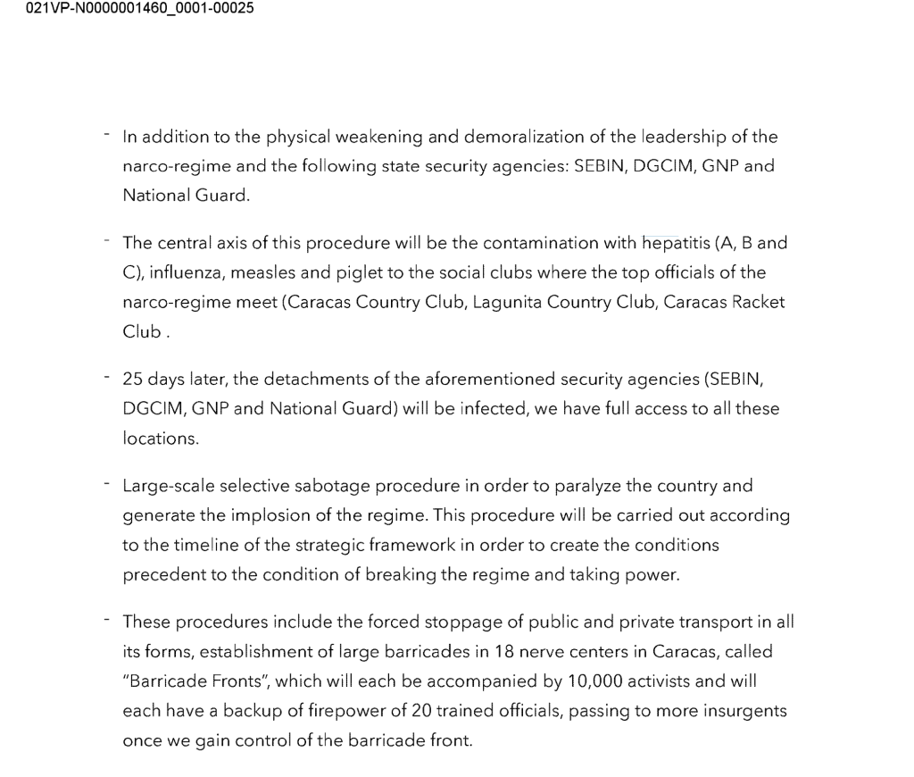

The proposal called for training 400 to 500 fighters at Camp Moyock, North Carolina, a training facility operated by the U.S. private military company Academi, formerly known as Blackwater. The camp was owned by Erik Prince, the right-wing heir and Trump associate who has vowed to lead an armed invasion of Venezuela to overthrow Maduro.
Goudreau dismissed that plan as virtually impossible, remarking to The Grayzone, “500 men versus a concentration of, say, 50,000 troops who have the run of a city and pretty decent air support with their Sukhois, versus Erik Prince’s helicopters… I don’t know that that would have ever scratched the paint.”
In an interview with The Grayzone, Obdola disavowed any knowledge of the document’s most alarming proposals, claiming the document was “manipulated” by one or more of the opposition figures who signed it. He confirmed that the digital signature on the document was his but expressed surprise that the document had been emailed to Drew Horn – even though the message originated from Obdola’s personal email address.
Obdola had been involved in previous efforts to impose a so-called transitional government on Venezuela, but has since broken with Guaidó’s team, whom he lambasted as “vultures,” claiming they were apportioned huge sums of money by the US government but ended up “stealing everything.”
While the Venezuelan opposition may have never implemented Digital Democracy’s proposals for nationwide terrorism, US intelligence has continued to wage sabotage attacks inside the country in vain hopes of inspiring a rebellion against Maduro.
Around 5 PM on March 7, 2019, Venezuela experienced the most severe blackout in its history following a supposed malfunction at the Simon Bolivar hydroelectric dam. Perched on the edge of the massive Guri reservoir, the plant provides nearly three quarters of the nation’s electrical supply.
Within minutes, then-Senator Marco Rubio took to social media to celebrate. “18 of 23 states & the capital district are currently facing complete blackouts. Main airport also without power & backup generators have failed,” Rubio wrote. It was unclear at the time how a US Senator would have access to such detailed information regarding Venezuela’s power grid, especially given that Caracas had yet to issue a statement.
As Venezuela plunged into darkness, Secretary of State Pompeo joined in the celebrations. “No food. No medicine. Now, no power. Next, no Maduro,” Pompeo exclaimed. Not to be outdone, Juan Guaidó wrote on Twitter: “the light will return when the usurpation [of Maduro] ends.”

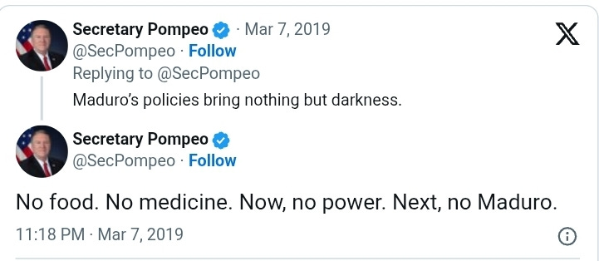

Further US acts of sabotage were detailed in a 2024 article by Wired which revealed that in 2019 the CIA executed a cyberattack on the payroll system responsible for disbursing the salaries of Venezuelan soldiers, citing four members of the Trump administration and officials at Langley.
While the covert US attacks irritated the Venezuelan government, they failed to produce any change on the ground. And in the meantime, Goudreau’s plot continued to take form.

Planned meetings with John Bolton and Elliot Abrams
According to Sainz, the former State Department official, by the time Global Governments met with Betancourt on May 11, 2019, everyone present knew Goudreau was preparing a military operation for Venezuela. At that meeting, Sainz said Schiller explicitly instructed him that any details for the White House should be passed through him.
Sainz also said that Kraft promised to reach out to contacts in the State Department, as well as John Bolton—then-White House national security adviser—and Elliott Abrams, then-U.S. special representative for Venezuela. Both Bolton and Abrams are perennial fixtures in Republican White Houses, and have spent decades attempting to overthrow independent-leaning governments across the globe. While serving as Under Secretary of State for Arms Control for George W. Bush, Bolton helped fabricate evidence Iraq sought ‘yellow cake’ uranium from Niger.
As Trump’s chief of staff, Bolton obsessed over toppling governments from Tehran to Caracas. Nicolas Maduro held Bolton personally responsible for the failed attempt to assassinate him with explosive-laden drones during a military parade in 2018, telling The Grayzone’s Max Blumenthal during an interview a year later, “John Bolton tried to kill me.”
During a July 2022 interview with CNN, Bolton described himself “as someone who has helped plan coups d’etat – not here, but you know, other places.”
Abrams, for his part, was convicted for lying to Congress about his role in the Iran-Contra affair, having found a variety of creative methods to funnel funding to opposition death squads in Central America after the US legislature explicitly forbade the Reagan administration from doing so. The neoconservative operative was later identified as the Bush administration official who greenlit the coup against Huge Chavez in 2002.
According to Sainz’s statements to the FBI, Kraft mentioned that SOUTHCOM Commander Craig Faller had demanded a level of “transparency” in the operation. Taken together, these statements by high-ranking American officials gave Sainz reason to believe Kraft was communicating with the U.S. government and said he felt this “provided validation for their operation.”
Separately, Goudreau told The Grayzone that Betancourt had also held meetings with both Abrams and Pompeo. “It was strange that Betancourt was meeting with Abrams and Pompeo,” Goudreau remarked to The Grayzone. “He was a complete and utter buffoon.”

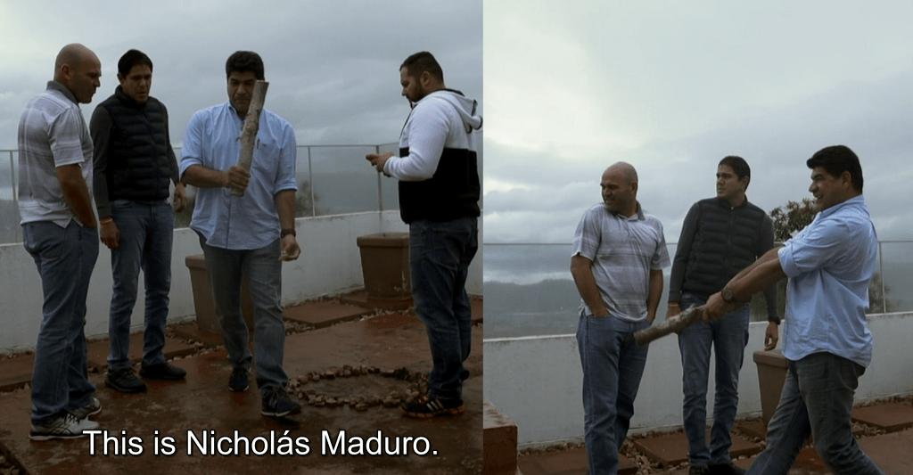
Jorge Betancourt swats a rock representing the Venezuelan president off a Bogota balcony as Lester Toledo and an unidentified man observe.

‘Next steps’ to ‘recapture the country’
On May 14, 2019, Sainz emailed Kraft, Schiller, Lucas, and two other Global Governments affiliates. He opened by advising the recipients not to share the email’s contents with outside parties. In the message, Sainz provided a summary of his recent meeting with Betancourt. The gathering was also attended by his brother, Pedro Paul Betancourt, a would-be political consultant who was at one point employed by López’s Voluntad Popular party; Hector Di Bonaventura, who Sainz described as “Toledo’s right-hand man from Miami”; and Daniel Echenagucia, a Venezuelan-Italian who was arrested in Venezuela in 2024 and charged with conspiracy, criminal association, terrorism, financing terrorism, and treason.
Sainz told the Global Governments leaders that the meeting began with a “summary of the situation on the ground” in Venezuela provided by Betancourt, whom Sainz described as “the senior voice behind Leopoldo López.” Betancourt’s rundown contained segments on not just “humanitarian aid [and] human rights,” but on far more dangerous issues including “rebellion strategy” and “military support.” Ultimately, Betancourt was given responsibility for coordinating “all matters associated with the Liberation of Venezuela,” Sainz wrote.
With the “current regime… broke” and “unable to address the future needs of the military,” Sainz paraphrased Betancourt, the opposition had therefore “ceased [sic] this opportunity to create a channel of communication with the armed forces.” As part of this military outreach, “the opposition created a data – matrix of key military personnel” in Venezuela, which included the soldiers’ “complete names, rank, address, extended family, etc.,” Sainz wrote – a move which any military in the world would interpret as hostile.
The email, and approving responses by Kraft, made it abundantly clear that everyone on the Global Governments team was aware of plans by Goudreau and top Venezuelan opposition figures for a violent coup attempt against Maduro. The only dispute was over how to execute the plan.
According to Betancourt, there were three objectives: first, “to create and execute an overall strategy to oust the current regime;” second, to implement a “Sustainability Strategic Plan” during the “transition period”; and third, “recapture the country.”
It was this second phase, during which the group had removed the Venezuelan government but not yet replaced it, which “keeps Mr. Betancourt awake” at night, Sainz stated, adding that “he and others are very concerned that when they take power they will not be able to sustain it.” In order to flesh out the details, Betancourt proposed establishing three “working groups” in Washington, Miami, and Bogota, Sainz wrote.
For the Washington-based group, “Mr. Betancourt expressed his interest for Global to work with members from The Rendon Group,” Sainz wrote, referring to the CIA-linked PR firm which Goudreau linked to sabotage attacks inside Venezuela.
Betancourt’s document concluded with a list of “next steps,” which included a “video conference with Leopoldo” López and a proposal to “organize and coordinate Jordan’s visit to Bogota.”
About a week later, on May 20, Sainz, Schiller, Kraft, Toledo, and Betancourt gathered in a room at the Hilton hotel in Boca Raton, Florida, and held a video conference call with López, the power broker of the Venezuelan opposition.
Sainz recalled Schiller taking a more active role in this May 20 meeting, telling the Venezuelan opposition figure that he “could count on them and that they were there for him.” As the discussion concluded, Sainz recalled Schiller handing out pens from the White House and Challenge coins from his time inside the Trump administration.
Sainz told the FBI that these trinkets gave the participants the impression that the White House stood firmly behind the project.

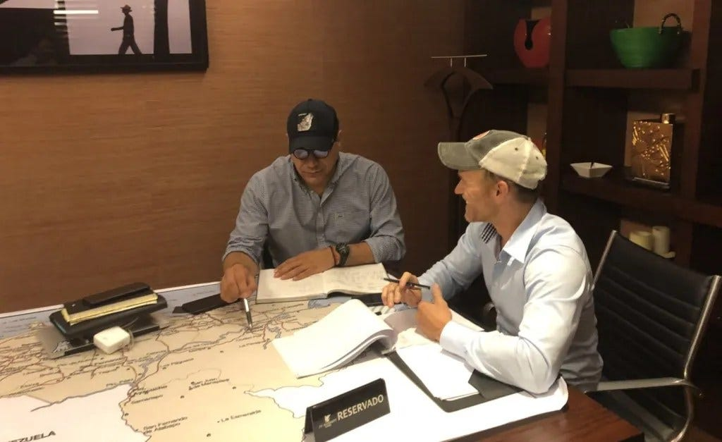

Betancourt and Goudreau strategize at their makeshift headquarters in Colombia. (Photo courtesy of Jordan Goudreau)

The ‘Rebellion Strategy’
By June, Goudreau was holed up in a house 25 minutes outside Bogotá alongside Toledo and Betancourt. Inside, according to Toledo, the American had transformed the place into a Hollywood-style war room, with maps of Venezuela and coordinates laid out on tables, alongside photos of top targets including Maduro, top ministers Jorge and Delcy Rodriguez.
Posted on one of the wall were slips of paper with code words representing the steps to be taken before, during, and after the coup to ensure its success. The most prominent code word, “Narative,” was spelled incorrectly.

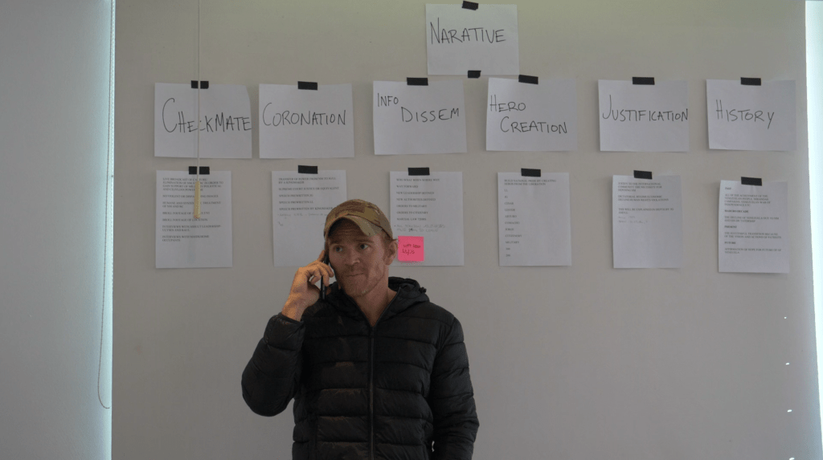

Goudreau and Betancourt remained at odds as to how the operation would be carried out, however. A photo dated June 2, 2020 showing Betancourt’s proposed “Rebellion Strategy” was outlined in a hand-written battle plan which contained various code names for its executors and its high-level targets among the Venezuelan government. The plan featured a timeline calling for prison riots, “misinformation,” a “misdirection” campaign in Venezuela’s Pomones region, “black ops,” and an apparent attack on Venezuela’s fleet of Sukhoi attack jets. It would all culminate somehow with a “popular rebellion.”
According to Goudreau, the document was drawn up by Betancourt – who featured himself at the top of the chain of command. The former Green Beret said Betancourt and Toledo planned to pay opposition members to stage a series of jailhouse riots to generate instability as a step toward a nationwide uprising.

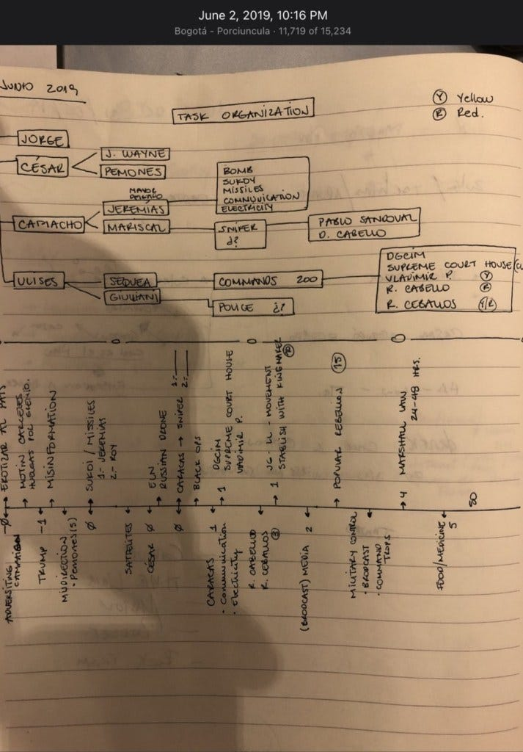

“Betancourt and Toledo couldn’t get the popular rebellion thing out of their head,” Gourdreau said. “I always thought it was ridiculous since it failed on April 19 [2019]. I thought very little of this plan but placated Betancourt.”
He continued: “I knew I would need powerful people in the military. The problem is that the Venezuelan military hated Betancourt, Toledo, Leopoldo [López] and Guaidó, and didn’t trust them. And rightly so.”
Goudreau added that Betancourt and his crew despised the Venezuelan military leadership so viscerally, particularly Defense Minister Vladimir Padrino and then-Constituent Assembly Diosdado Cabello, that they obsessed over killing them. “They became enraged when I said these men should be allowed to flee or be captured,” he recalled.
On June 19, 2019, Goudreau unveiled his own master plan for regime change in Venezuela during a meeting at the JW Marriott hotel in Bogotá, Colombia with Sainz, Toledo, and Betancourt.
The meeting quickly veered off the rails when the Venezuelan opposition activists found themselves across a table from a highly decorated former Venezuelan military officer named Clíver Alcalá. While serving as a Major General under Chavez, Alcalá appeared loyal to his country’s Bolivarian Revolution. But after Maduro’s election, he clashed with the new president and crossed over into the opposition. Guaidó’s associates viewed Alcalá with deep suspicion, not only because of his Chavista past, but due to rumors of his involvement in the drug trade. They fretted that his presence could tarnish their image among their backers in Washington.
Toledo told the FBI he was shocked to see Alcalá involved, claiming that he believed the former Venezuelan general was involved in narcotics trafficking. And with his history as a Chavista, Toledo said meeting him was like “coming face to face with the enemy.” Goudreau, however, contended it was Toledo who introduced him to Alcalá in the first place.
Alcalá was assigned the code name “Cesar” during the planning phase of Operation Gideon. He dedicated himself to training the Venezuelan deserters, who had been largely abandoned by Guaidó after they heeded his call to lay down their arms and flee to Colombia amid the failed coup in April 2019.
“General Cliver Alcalá was in charge of the operation,” Goudreau explained. “So I was going to link up with Venezuelan military units that Alcalá had accrued inside of Venezuela, and we were going to catalyze a rebellion.”
Goudreau insisted that his own role would be to convey US support for the plot in order to ensure its success: “We needed the Venezuelans on the ground to see the face of a gringo to realize that this was actually going forward and this was trusted – that this had US support.”
The special forces operator was initially wary of Alcalá, suspecting the general was still “a Chavez guy” at heart. But throughout their time together, “he never lied to me once [and] showed no signs of deception,” Goudreau said. In the end, the Green Beret veteran concluded that Alcalá would be a useful ally, as his military credentials could help draw other Venezuelan forces to their side during the planned coup. Goudreau also believed that Alcalá could help to represent the interests of more moderate opposition factions who disliked Guaidó.

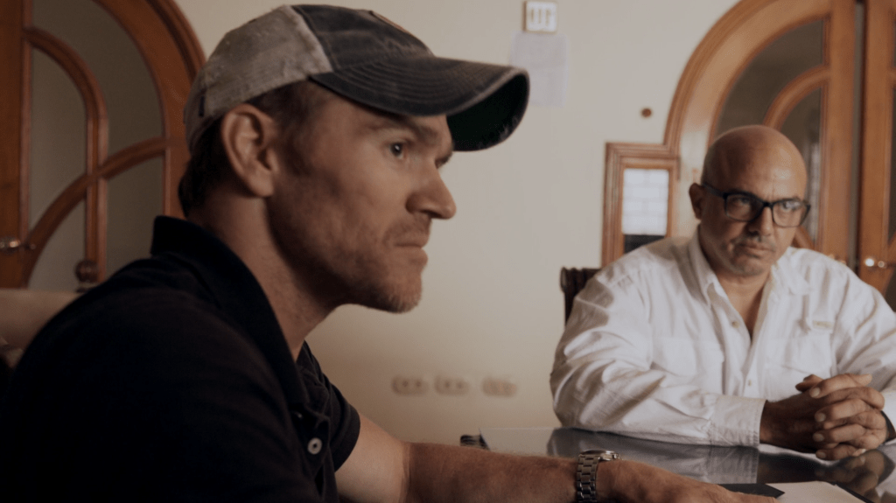

Jordan Goudreau with Cliver “Cesar” Alcalá in Colombia, 2019
Alongside Alcalá, Goudreau devised a plan for several US special operations veterans to train the handful of Venezuelan military defectors who’d been exiled in Colombia since Guaidó’s failed coup in 2019. When the time came to strike, Goudreau claimed his team would infiltrate Venezuela and link up with Venezuelan military units who were supposedly prepared to turn against Maduro. Toledo told the FBI that he considered it a “suicide mission.”
Goudreau denies suggestions that he sought to capture or kill Venezuela’s sitting president, claiming he would have only needed to distract Maduro and keep him on the run long enough to install an opposition junta.
Goudreau realized that many of the Venezuelan opposition figures opposed allowing Alcalá to hold any prominent role in post-Maduro Venezuela – a group which the special forces operator suspected included Betancourt and Toledo. He said his suspicions were confirmed after he secretly arranged to record a conversation with Betancourt and Toledo during the June 2019 meeting at the Marriott in Bogotá.
The figure who carried out the undercover taping was a former Venezuelan National Guard commander, Arturo José Gómez Morante, whom the Maduro government accused of several kidnapping operations in the country this year.
In the recording, Betancourt and Toledo openly disparage Alcalá and discuss their desire to constrain the general’s role in the operation. They further discussed their willingness to rehabilitate and help lift US sanctions on some of the prominent Venezuelan leaders working to oust Maduro, but not Alcalá.
Toledo can also be heard acknowledging that he took a trip to Colombia to discuss the plot with Colombia’s rabidly right-wing, pro-US former President Alvaro Uribe, who allegedly approved it. He described Colombia’s then-Ambassador to the US, Francisco Santos Calderón (known locally as Pacho Santos) as “the one who’s organizing all this.” In the comments, Toledo says Santos sought to use the Venezuelan opposition’s militia of deserters to launch a strike against left-wing paramilitaries known as the ELN, or National Liberation Army.
“I went to talk to Ambassador Pacho Santos, who, in my opinion, is the one with the biggest balls in this shit, he’s crazy,” Toledo says. He recalled that the Colombian official “proposed what he calls a staged plan” in which the Venezuelan opposition would “get 38 guys, we’ll go there, we’ll give those sons of bitches from the ELN a beating and back off!”
“Damn, finally they grow some balls, brother,” he added. Per Toledo, Santos told him he had “only one request from Uribe’s government – That at some point we have to start coordinating between the people from the CIA and the people here.”
“And there’s only one guy: Juan Cruz, who’s a very skilled guy,” Toledo said, referring to the former chief of the CIA’s Latin American operations. “Why do they trust Juan Cruz so much? They trust Juan Cruz because he used to be the head of the CIA here.”
Toledo insisted he had never met Cruz before, until he was introduced by the Colombian ambassador. Nonetheless, due to Cruz’s leadership role in Langley, “We trust him – not even Trump, but him.”
When the man recording, Arturo Morante, noted that this means “the CIA has to know” about their plans in Venezuela, Toledo confirmed: “of course.”
Toledo went on to state that once the CIA and the Colombian government had committed to supporting the plan, “I’ll lay down the track, I’ll bring in weapons, I’ll do the whole thing.” However, he said, one “problem” remained: “A problem whose name starts and ends with Cesar,” using the code name for former Major General Cliver Alcalá.
According to Toledo, Leopoldo López had presented him with a list of 22 names whose inclusion in any operations would be considered a violation of a “red line.” Toledo recalled López bluntly stating, “We are willing to endorse whatever with whomever except with these 22” – and “the first one is Cesar.”
Toledo later told the FBI that when learned he was secretly recorded, he concluded that Morante was compromised based on this fact. But even as the dissension grew within his circle of Venezuelan contacts, Goudreau pushed ahead with his operation.

A contract to “capture/detain/remove”
Back in the states, the CIA wasn’t the only group alleged to have given its blessing to the operation. According to Sainz’s FBI testimony, Kraft claimed he met personally with President Trump after a campaign rally in North Carolina in the summer of 2019. During the conversation, he said they discussed how to arrange weapons and funding for the project.
For his part, Goudreau says Kraft told him he met with Vice President Mike Pence at an event that summer and informed Trump’s second-in-command of the Venezuela project’s status. But even though he continued making the rounds at the White House, the businessman failed to provide the funding Goudreau needed.
In the ensuing months, Goudreau says he initially believed his Global Governments contacts, and Kraft in particular, would compensate him for work carried out by his team. But by the summer of 2019, Goudreau’s expenses were piling up, and Global Governments was still not reimbursing him.
In his FBI interview summary, Toledo said he cut off contact with the Green Beret following a volatile meeting which ended in a fierce argument. In Toledo’s telling, Goudreau demanded payment for his work on the project. When he refused, he says Goudreau offered to show him weapons in the trunk of his vehicle outside – upon which he says he told Goudreau “to leave” his office “and not come back.” Toledo now maintains that he subsequently informed the five top-ranking Venezuelan opposition members about the interaction, warning that the “loose cannon” Goudreau was “crazy.”
But even though Kraft had proved an unreliable financier and Toledo dismissed him, Goudreau hadn’t exhausted all of his options. In the summer of 2019, Goudreau said other Venezuelan associates connected him with Juan Jose “J.J.” Rendón, a wealthy, Ted-talking celebrity consultant for pro-US Latin American politicians (with no relation to The Rendon Group). Having successfully managed the presidential campaigns of Colombia’s Alvaro Uribe, and served as his chief strategist while in office – facing allegations of surreptitious payments from local drug lords in the process – Rendón remained the brains behind his country’s right-wing.

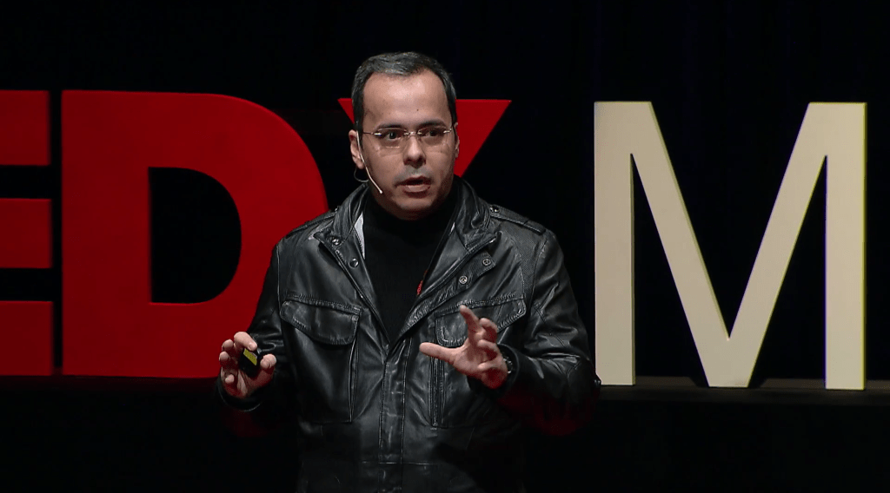

J.J. Rendón delivers an address on “neo-totalitarianism” in Venezuela at the 2014 TEDxMidAtlantic conference in Washington, D.C.
Rendón’s influence carried over the Venezuelan border, where he served as an influential guide of the US-backed opposition. By the time Rendón came into contact with Goudreau, Guiado had appointed him as director of his Strategy Committee to explore options for toppling Maduro.
Over the course of the next several months, Goudreau and Rendón negotiated a contract for Goudreau to carry out his Venezuela coup with financial backing from Guaidó’s movement. The document authorized his group to use lethal force and detain civilians, and set out the rules of engagement to be used, depending on the level of anticipated “collateral damage.” It stipulated that Goudreau and his American colleagues would do whatever possible to “conceal their identity” in order to ensure that the coup was perceived as “Venezuelan only.”
Under the terms of the deal, Goudreau’s company, Silvercorp USA, would receive a non-refundable retainer of $1.5 million to prepare the coup.
The contract specified the goal of the operation: to “capture/detain/remove” Maduro and the current regime from power, and install Guaidó in its place. When that happened, Goudreau would receive a “success bonus” of $10 million. The “estimated total project cost” for the operation was $212.9 million. If the coup proved to be unsuccessful, the document contained a highly unusual clause allowing Guaidó’s pseudo-administration to deny any and all knowledge of the plot.
What’s more, the contract listed Guaidó at the top of the operation’s chain of command. Not only did Goudreau believe he had the backing of the White House, the contract assured him that he was acting with the blessing of Venezuela’s US-backed “interim government.”
However, some of Guaidó’s closest collaborators were apparently beginning to develop cold feet about the coup. Toledo pointed to an Oct. 15, 2019 meeting in Colombia which was organized by Colombian intelligence chief Rodolfo Amaya and reportedly included a CIA representative. During this encounter, Toledo said the attendees drafted a memo assessing that the Maduro government had infiltrated Goudreau’s network.
Goudreau told The Grayzone that before the meeting in Colombia between Betancourt, Amaya and the CIA official, Venezuelan opposition leaders were “hell bent on flipping Venezuela.” But afterwards, “everything changed.”
He assessed that the CIA officer who organized the meeting was Juan Cruz.
Toledo told the FBI he was uncertain if Guaidó was immediately informed of the anti-Goudreau memo originating from Betancourt’s Colombia meeting, but that Rendón continued to meet with Goudreau.
Despite the clear warning signals, Guaidó signed a contract with Goudreau exactly one day later, on October 16, 2019.
Though it’s not shown on video, The Grayzone has reviewed an audio recording of the signing and assessed that the participant’s voice strongly resembles that of Juan Guaidó. In the time since, Guaidó has repeatedly denied signing any contract with Guaidó. He now insists that the signature on the contract was forged by the Maduro government – a notion which one survey showed less than 5% of Venezuelans found plausible. In the following days, Rendón wired Goudreau $50,000 as a down payment on the retainer fee, and the parties finalized the deal.

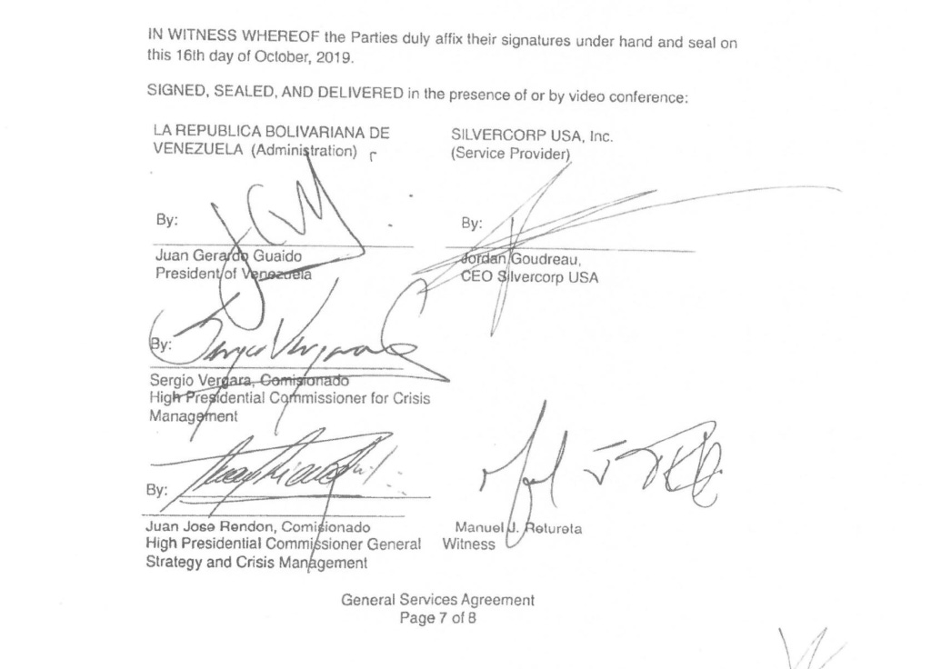
An image of Goudreau’s General Services Agreement with the Venezuelan opposition bears the distinctive signature of Juan Guaidó.
Throughout the course of negotiations, Goudreau kept Global Governments in the loop, providing Sainz a draft of the agreement. Sainz told the FBI he advised Goudreau to seek legal advice and shared the details of the contract with Travis Lucas, the DC lawyer who works closely with Mike Pompeo.
In interviews, Goudreau has explained that having a contract with Guaidó which authorized the operation was more important than the financial compensation the contract described. Nevertheless, Goudreau is currently suing Rendón for breach of contract due to his failure to pay out the rest of the retainer.
Within a day or two of signing the contract, Goudreau said he met at the Trump International Hotel in Washington with Lucas and another attorney named George Sorial. Sorial had served as the executive vice president and chief compliance counsel at the Trump Organization from January 2007 to June 2019. Goudreau said the three of them gathered to discuss his contract with Rendón.
In his FBI interview, Sainz recalled Goudreau telling him about this October 2019 Trump hotel meeting with Lucas and Sorial. Sorial, however, told The Grayzone, “I had no contacts with [Goudreau] and do not even recall ever meeting him.”
During this period, Goudreau said he also crossed paths with Trump’s former security chief, Schiller at the White House. Goudreau said they discussed the potential financial windfall to come, and Schiller affirmed “the boss’s support” for Goudreau’s efforts.
White House visitor logs shared with Goudreau’s legal team show Schiller visited Trump at the White House on Oct. 16, 2019 – the same day the contract was signed. Speaking to the FBI, Schiller acknowledged meeting Goudreau at the Trump Hotel, but insisted he didn’t discuss Global Governments or Goudreau’s operation with Trump or administration staff.

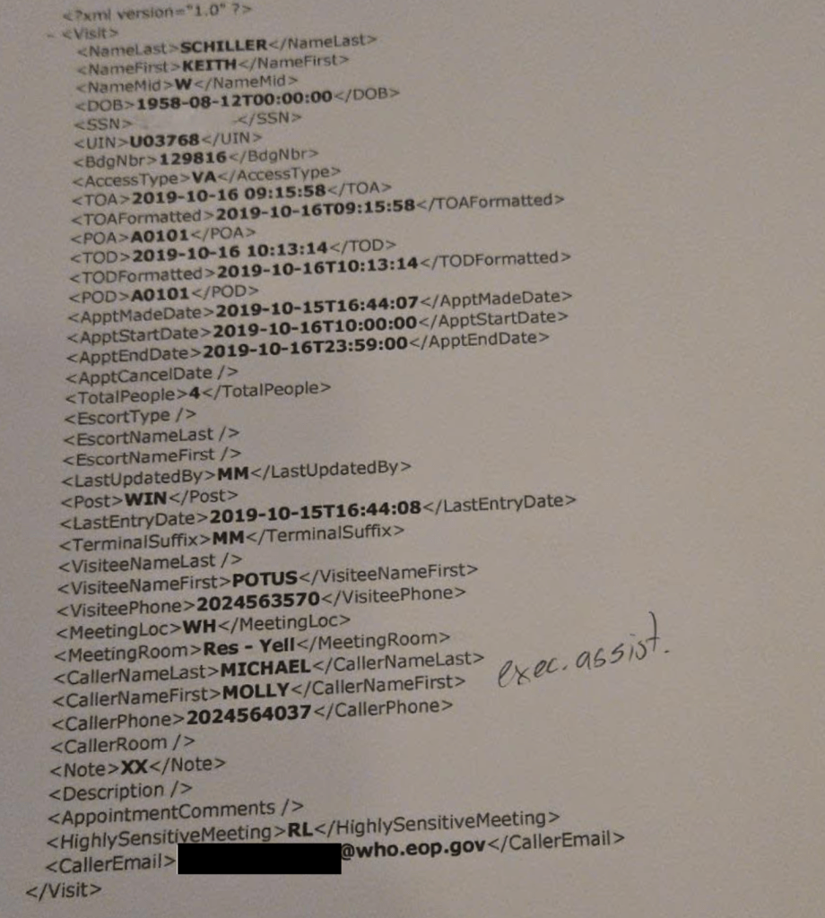

But even if truthful, his denial does not undermine Goudreau’s claims that the White House authorized the operation.
Around the time the contract was formalized, Goudreau clued in another Green Beret veteran named Drew Horn following an introduction by Lucas. At the time, Horn was serving as a policy adviser to Vice President Pence.
When interviewed by the FBI in September 2021, Horn described the meeting with Goudreau as having a “cloak and dagger” feel. Under the ground rules set by Lucas, Horn recalled, he and Goudreau were only supposed to know each other by their first names, and Lucas assured Horn that what Goudreau was doing in Colombia was humanitarian-related and legal.
In response to a request for comment about his interactions with Global Governments and Goudreau, Lucas wrote, “As an attorney, I cannot and do not discuss my interactions or communications with prospective clients or clients. I can, however, state unequivocally that I played no role whatsoever in the failed coup attempt in Venezuela, had no knowledge about the coup attempt before it transpired, and never discussed or communicated with any U.S. government official regarding a coup or uprising in Venezuela. Any suggestions to the contrary are completely false.”
However, an invoice provided by Goudreau showing he spent $30,000 retaining Lucas’ legal services specifically references “navigating any federal laws” related to ITAR, the US government regulation system which handles the import and export of firearms.

‘We don’t care how bloody it gets’
The available evidence is even more incriminating for Horn. Transcripts of his communications with Goudreau on the Signal encrypted messaging application show Goudreau and Horn chatted extensively and met in person on multiple occasions between November 2019 and February 2020, text records show.
During his FBI interview, Horn expressed regret over his interactions with Goudreau. The interview summary states Horn said he “acted like an idiot and should have looked into Jordan Goudreau before offering any kind of help.”
On Nov. 26, 2019 text messages between Goudreau and Horn show the pair introducing themselves around 11 AM. That evening, the Vice Presidential aide suggested the pair meet up at 2 PM the following day at a restaurant called P.J. Clarke’s – located in between the White House and the Global Governments office on K Street – where “they have a basement that’s pretty quiet at that time.” Five minutes after the meeting was set, Horn texted Goudreau, “I talked to my state [department] contacts too, good conversations.”
At the meeting the next day, Goudreau says Horn told him: “We don’t care how bloody it gets, when this is done, the money will flow.”
“He was incredibly excited that someone was working on this,” Jordan told The Grayzone. “We worked together for several months to try to push this forward,” and Horn “relayed… at the highest level that this was authorized.”
Also in attendance that day was Jason Beardsley, another Green Beret veteran whom Horn knew.
At the time, Beardsley was working as a Department of Veterans Affairs employee. Email traffic obtained through discovery indicates Horn was pitching Beardsley’s resume in the fall of 2019 in an effort to help him find a job in special operations or counter-terrorism at the Department of Defense. In one email, Horn touted Beardsley’s experience in “white and black sof” [special operations forces] – the latter of which refers to JSOC operations. Beardsley confirmed his membership in the “JSOC community” in a 2023 podcast.
In a February 2022 FBI interview, Beardsley said he recalled only meeting Goudreau in person once, and insisted that the pair exchanged just a few text messages afterwards. Beardsley told the bureau he did not recall ever speaking with Goudreau by phone.
When interviewed by the FBI about the interactions, Beardsley described Goudreau as “a cowboy and door kicker,” and claimed his only goal in the interactions was “unwinding” Goudreau from his Venezuela plans.
In response to their efforts to distance themselves from him, however, Goudreau points out that Horn and Beardsley continued to solicit communication with him during this period.
Text message records show Horn contacted Goudreau on Signal on Dec. 9, 2019 to inform him that Beardsley had developed the scheme further. “We’ve war-gamed things out to the best of our ability, [Jason’s] got the next step,” Horn’s text reads.

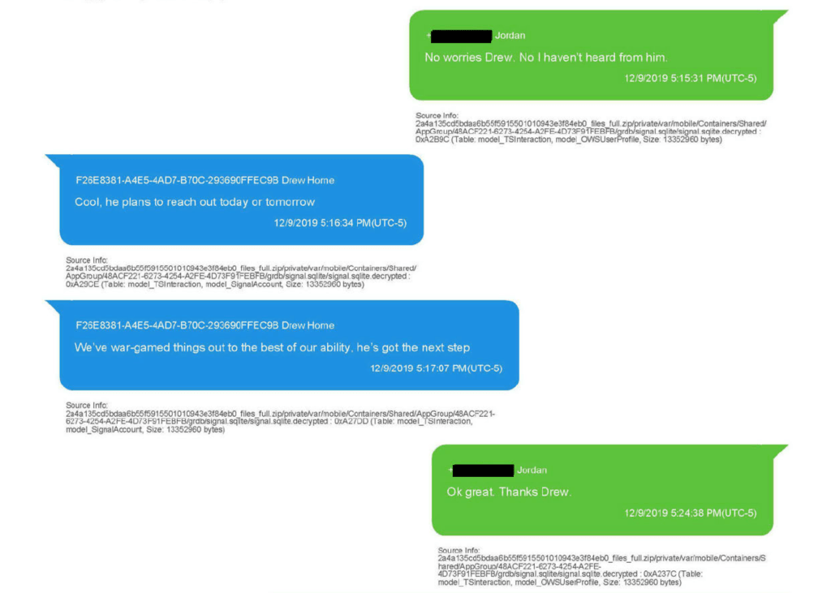

White House visitor logs indicate Beardsley attended a Dec. 10 White House meeting with Joseph Wier, then-director for foreign military sales at the National Security Council (NSC). By this point, the only supplies heading to the Venezuelan defectors in Colombia were non-lethal, and had been donated by an arms dealer in Miami, according to Goudreau. Though he declined to name the individual responsible, Goudreau described him as a “gentleman in Miami – a Venezuelan, a patriot” with “contracts in South America to sell firearms and tactical gear.”
The FBI appeared to believe that was Mark Von Reitzenstein, an arms dealer based in the Venezuelan expat community of Doral, Florida. Von Reitzenstein’s company High End Defense Systems currently claims to outfit the Ecuadorian military and the Israeli army.

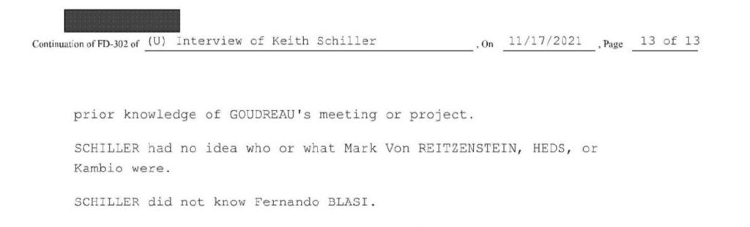
Those interviewed by the FBI disavowed any knowledge of High End Defense Systems (HEDS), or its owner, Mark Von Reitzenstein.
That evening, Beardsley texted Goudreau, “Haven’t forgotten, ran some thoughts by a decent gent in oversight of NSC who’s trusted.” Explaining this text to the FBI two years later, Beardsley claimed that although he was talking with someone at the NSC, he didn’t discuss Goudreau, and insisted he only mentioned this to the Green Beret because he thought Goudreau was trying to skip out on a meeting.
On Dec. 11, 2019, Beardsley sent Goudreau a series of texts requesting another in-person meeting. Beardsley also described “interested parties,” which he said would be “comprised of equity, finance, political, ops, regional [subject matter experts].” They planned for a Dec. 16 meeting, but the texts indicate Goudreau asked to reschedule, stating, “I have to be down south this week.”
Beardsley told the FBI that he would have used this Dec. 16 meeting to scrutinize Goudreau’s plans. Beardsley said his reference to “interested parties” was an attempt to “shock reality” into Goudreau and get him to “put up or shut up.”
While Beardsley claimed these texts were part of his way of “unwinding” Goudreau, they came at what then-Defense Secretary Mark Esper described as a period of renewed interest in Venezuela within the White House and National Security Council.
In his 2022 memoir, Esper wrote that, during a December 12, 2019 Pentagon meeting, then-national security adviser Robert O’Brien informed him of several new projects in the works, including “next steps in Venezuela.”

Kraft meets “The Little Doctor” and “Baby Eater”
Throughout the final weeks of 2019, Timothy Roen Kraft said he held regular phone calls with Leopoldo López, the opposition honcho who had taken sanctuary in the Spanish embassy in Caracas after his failed military coup earlier that year. López wanted to know if Goudreau had any chance of capturing Maduro. According to FBI agents’ notes, “Kraft said no one would get that close to Maduro. Kraft thought Goudreau and everyone around would get killed. López did not really react to Kraft’s response.”
During the Christmas holiday, Kraft was at his family home in Minot, North Dakota when he learned that Guaidó sought a meeting. The self-proclaimed Venezuelan interim president had lost momentum since his failed military coup in Caracas, and was the subject of a Washington Post profile earlier that month which proclaimed in its headline that “the flame [Guaidó] lit is petering out.”
On December 27, 2019, two Venezuela opposition figures acting on instructions from Guaidó’s mentor, López, landed in a rented Learjet on a frosty airfield in Minot and headed straight to lunch with Kraft. One of the men was covered in colorful tattoos, including a design depicting a chemical formula. He introduced himself to Kraft as “The Little Doctor,” and would only provide his first name. The other man, who claimed to be named “Carlos,” also maintained anonymity throughout the meeting. (Guaidó’s “ambassador” to Washington was named Carlos Vecchio.) Kraft recognized the men as intelligence operatives with connections inside the Venezuelan military, referring to their extensive tradecraft in his FBI interview.
The FBI later identified “The Little Doctor” as Cesar Omaña, a Venezuelan opposition operative who is little known outside his country, but who has played a pivotal role in various conspiracies to undermine Maduro’s government. He is credited with helping López escape from the Spanish embassy in Caracas and move abroad in 2019, and was photographed that same year alongside another top opposition figure, former Caracas police chief Ivan Simonovis following his escape from house arrest, as he served a long sentence for his role in deadly violence during the 2002 coup that briefly deposed then-President Hugo Chavez.
According to NBC News, Omaña worked through US government channels and with two other foreign governments (likely Spain and Colombia) to organize Simonovis’ escape. Simonivis subsequently became a US government asset, and was described in the FBI’s interview with Nestor Sainz as “very valuable.” (The former police chief is now identified as security director for Maria Corina Machado, the current de facto leader of Venezuela’s US-backed opposition).
Omaña also earned credit for recruiting the former chief of Venezuela’s SEBIN intelligence services, Gen. Manuel Christopher Figuera, as a US government informant. Described in the Washington Post as a “physician, businessman and adventurer” who had forged relationships within the opposition and Chavista circles, including a friendship with Chavez’s daughter, Omaña recruited Figuera for a planned May Day, 2019 uprising which never materialized.
Omaña appears close to Jorge Betancourt, allegedly covering his hotel bill at the JW Marriott in Bogota, Colombia while he stayed there for several weeks in 2019 with Jordan Goudreau – and where, according to Kraft, he and Lester Toledo ran up a hefty tab on prostitutes.

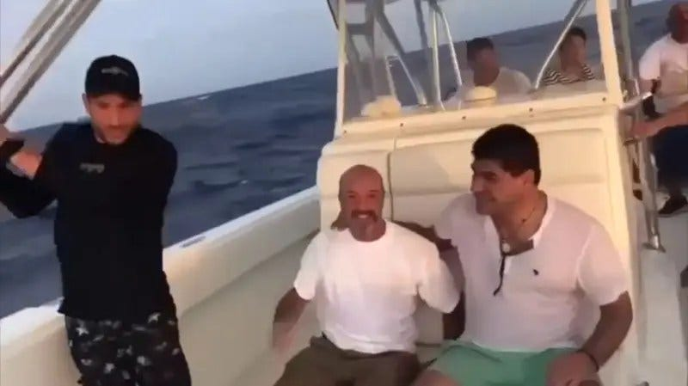

A still image from a 2019 video shows Simonovis (center) fleeing from Venezuela, seemingly accompanied by Omaña (left) and Betancourt (right).
Kraft told the FBI that Omaña and “Carlos” sought a contract with him for various business deals, and solicited his support for a series of treacherous plots against the Venezuelan government. The first involved taking over a pair of freighters which transferred oil from Venezuela to Cuba. The Guaidó operatives were confident they could commandeer the ships through crew members they had recruited to their side, and that they would be able to steer them to the US Virgin Islands and hand them over to American authorities.
Kraft responded favorably to the plan, but demanded a formal letter of approval from Pompeo, then the Secretary of State, before he signed on. Raising questions about his own involvement with US intelligence, he told the FBI he “could help in this situation by getting on board the ships and helping the captains override the wheelhouse and protecting areas of the ship. Once the wheelhouse was broken they could take the ship back.”
The next pitch presented to Kraft called for “making fake EU denominations to plant on Venezuelan diplomats from the regime while they were traveling to Europe for cocaine distribution activities.” The idea was to “discredit the currency” and thereby expose “how Venezuela played a big role in cocaine distribution in Europe,” Kraft said. But the proposal involved “too much tradecraft,” so the moneyman declined.

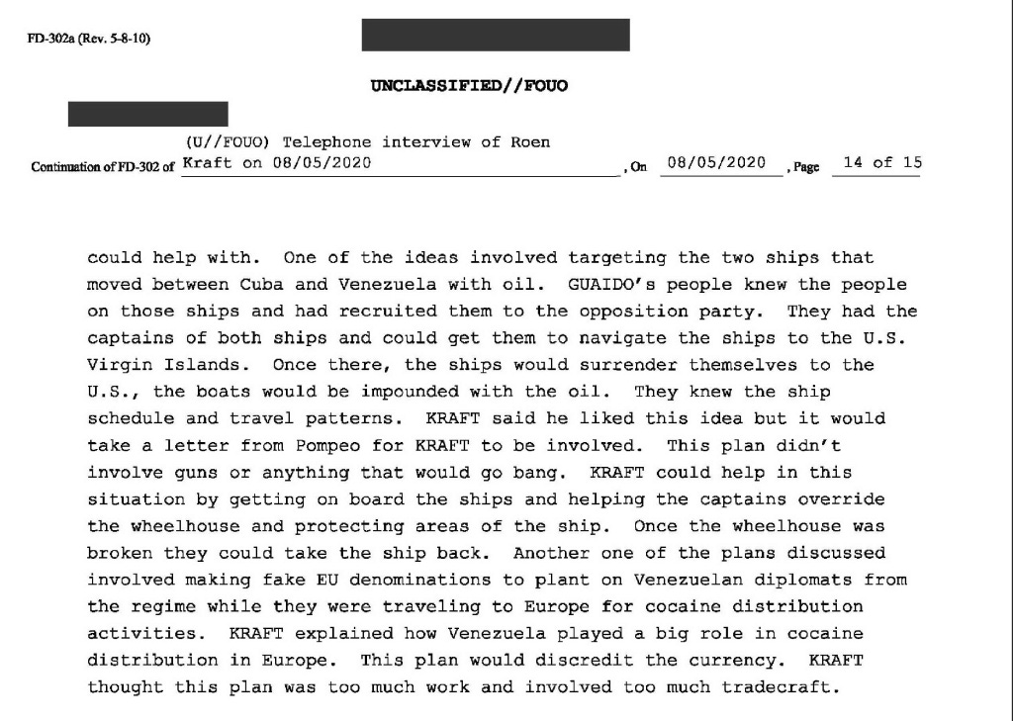

After the meeting, Kraft said he discovered the true identity of “The Little Doctor,” and began researching Omaña’s history. He discovered that “he had ripped the Venezuelans off for food” and “got a bad taste in his mouth about Omaña based on what he read.”
Suspicions about Omaña acting as a double or even triple agent have swirled within Venezuelan intelligence circles for years, including among fellow coup plotters. Today, rumors abound about Omaña dying under unusual circumstances after returning to Venezuela.
Following the meeting with Omaña and “Carlos,” Kraft agreed to meet another shadowy figure codenamed “Baby Eater.” He told the FBI he was waiting for clearance from Guaidó for the meeting.
According to the Washington Post, the NSC director for Latin America, Maurico Claver-Carone, was given the alias “Child Eater,” or Comeniños, during the failed May Day rebellion plot that Omaña organized with Figuera. Claver-Carone is a Cuban American lawyer who has exploited positions in both Trump administrations to organize regime change plots against the Venezuelan and Cuban governments. During the Biden administration, Claver-Carone took over as president of the IADB, but was fired after he was revealed to have given preferential treatment to a subordinate with whom he had an affair. Claver-Carone now serves as the US Special Envoy to Latin America.
If Claver-Carone was the same figure as the “Baby Eater” who solicited a meeting with Kraft, it would further Goudreau’s argument that high-level Trump officials were entirely aware of his coup plot.
Kraft went on to tell the FBI that he had discussed a contract with Guaidó for unspecified services, but that the self-described interim president would need to take some extraordinary measures to pay for it. “Kraft explained that Guaidó could have money if he was willing to turn over and work with the drug dealers,” he commented. “That would be a last ditch effort.”
Who those drug dealers were remains unknown, as Kraft has refused a request from The Grayzone for comment. The photos published in September 2019, which show Guaidó posing alongside two leaders of the Los Rastrojos drug cartel as they spirited him from Colombia to Venezuela, may offer a clue, however.

Gunning for Maduros
As Goudreau’s plot progressed, the Trump associate who initially recruited him applied for an international arms trafficking license.
On Dec. 31, 2019, the State Department sent a letter to Keith Schiller notifying him that it had received his application statement and fee to register as an arms exporter.
Schiller told the FBI he didn’t recall discussing arms export regulations in his interactions with Global Governments and Goudreau. Schiller acknowledged being registered as an arms broker but said he hadn’t taken advantage of this designation. He said he maintained the registration for future work with other contractors, but not Goudreau.
On Jan. 7, 2020, text logs show Beardsley reached out to Goudreau, asking, “how are things.”

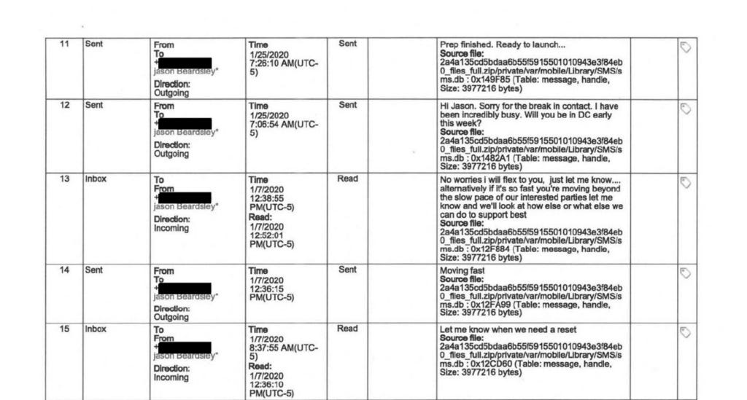

Goudreau answered, “moving fast.”
“No worries i will flex to you, just let me know…. alternatively if it’s so fast you’re moving beyond the slow pace of our interested parties let me know and we’ll look at how else or what else we can do to support best,” Beardsley replied.
Beardlsey told the FBI that this offer to find “what else we can do to support best” if Goudreau was moving faster than the “interested parties” was his way of telling Goudreau that he did not have U.S. government support. Beardsley told the FBI he expected Goudreau’s plans to “fizzle out” from there.
Goudreau scoffed at this explanation of the texts.
“If Beardsley wanted me to stop, he could have easily said, ‘Hey, listen, we’re going another direction. We need to cease ops.’ That would have been it.” But “he didn’t do that,” Goudreau said.
On Jan. 25, 2020, Goudreau texted Beardsley, stating, “Prep finished. Ready to launch…”
Beardsley told the FBI he didn’t know what Goudreau meant with this Jan. 25 text — a claim which Goudreau dismissed outright.
“We tend to use plain English in the military. Even in spy school and spy world, it’s just plain English,” Goudreau said.

Guaidó and the White House
By early 2020, with the groundwork laid, Goudreau had his team in Colombia—including Green Beret veterans Airan Berry and Luke Denman—training a ragtag band of Venezuelan opposition forces for the operation to oust Maduro.
Goudreau referred to the plan, including the infiltration of his team, the coup, and post-coup efforts to secure Venezuela and facilitate new elections, as “Operation Edgemont.”
The Venezuelan military defectors he worked with referred to their initial infiltration and tactical role in the overarching plan as “Operation Gideon.”
Meanwhile, Trump continued to emphasize his support for Guaidó. With the self-styled Venezuelan interim president at his Feb. 4, 2020, State of the Union address, Trump vowed “Maduro’s grip on tyranny will be smashed and broken.”
The following day, Trump hosted Guaidó at the White House.

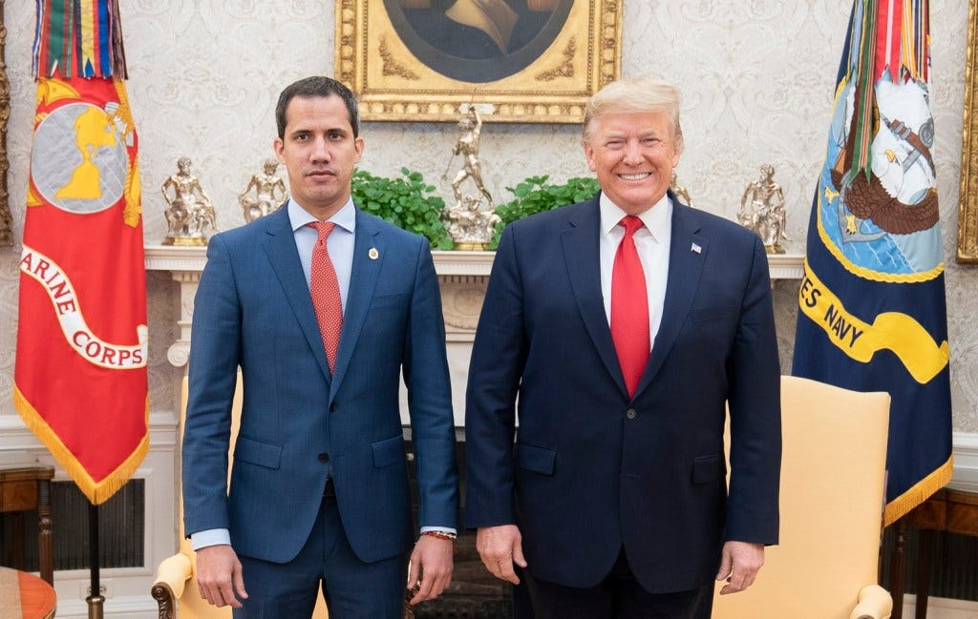

President Donald J. Trump meets with self-declared Venezuelan President Juan Guaido on Feb. 5, 2020, in the Oval Office of the White House.
In his book, Esper wrote that during Guaidó’s White House visit, Trump asked, “What if the U.S. military went down there and got rid of Maduro?”
Esper said the meeting moved over to the Cabinet Room. It was here that Esper recalled one of Guaidó’s colleagues saying, “We have some plans you [the U.S. government] know we are working on, they’re just not ready yet.” Esper said this individual briefly referenced Florida.
“As he finished the sentence, he smiled, looked away from me, and made eye contact with [Mauricio Claver-Carone], the NSC senior director who was pressing the hardest for military action. Claver-Carone smiled and nodded back,” Esper wrote.
The same day Guaidó visited the White House, Beardsley texted Goudreau, “Hope things are good, it was great to see Juan up there last night.”
“Let me know if there’s a need to continue doing background work to get you support,” Beardsley wrote in another text a minute later.
Asked about these texts by the FBI, Beardsley said no one in the administration was talking to him at the time about Guaidó.
Beardsley and Goudreau shared their last texts on Feb. 6. Their last exchange centered on a plan to meet on Feb. 14, 2020. Beardsley said this in-person meeting never took place. Soon after, he said he “ghosted” on Goudreau.
Horn told the FBI that in February 2020, Goudreau offered to credit the Trump administration if his Venezuela coup plan went forward. Horn told the FBI he rebuffed Goudreau’s offer and insisted the Trump administration rejected the idea of regime change.
Goudreau has denied Horn’s claims.
“I would think that if Drew Horn wanted me to stop, to cease and desist, he would have a written memorandum or an email sent to me to say, whatever it is, cease and desist,” Goudreau said. But “that was never relayed to me,” he notes.
Records show Goudreau and Horn continued to communicate through May of 2020. Horn declined a request for comment.

The Ides of March
Though elements of the Venezuelan opposition had lost faith in Goudreau’s plan, it wasn’t until Goudreau tried to move equipment that Operation Gideon began to unravel.
On March 23, 2020, Colombian authorities in the coastal Caribbean town of Pueblo Viejo seized a weapons shipment which included dozens of fully-automatic and semi-automatic AR-style guns at a roadblock. When the driver of the vehicle confessed that he was meant to deliver the guns to a man named “Pantera,” the Maduro administration quickly deduced that they were likely meant for a former Venezuelan army captain who was training deserters in Colombia – Roberto Levid “Pantera” Colina Ibarra.
In a televised address, Venezuela’s then-Communication Minister Jorge Rodriguez divulged details which made it clear that the plot had been infiltrated, describing the exact location of the training camps and naming Pantera as a subordinate of the “traitor named Cliver Alcalá.”
The situation worsened for Goudreau on March 26, when the US Department of Justice declared Alcalá to be one of the leaders of the “Cartel de los Soles,” a drug-running operation established among the Venezuelan military before the rise of Chavez. The Trump administration had apparently revived the long-dead “cartel” to justify placing bounties on Venezuelan leaders they sought to capture, while burying the operation’s sordid origin story.
In 1993, former DEA chief Judge Robert Bonner told 60 Minutes that the Cartel de los Soles imported over a ton of cocaine to the US under the direct watch of the CIA. The program quoted the DEA’s agent in charge in Caracas, Annabelle Grimm, as stating: “The CIA and the Guardia Nacional wanted to let the cocaine” enter the US, “without doing anything… no surveillance, no nothing.” After Chavez’s ascent, the Cartel de los Soles became a useful bogeyman, justifying American anti-drug operations which had been initiated by the US government.
Upon learning that Alcalá stood accused of heading the supposed cartel, Goudreau contacted Horn, wondering how the news would impact his plans. Text messages reviewed by The Grayzone show Horn asking him, “Do you want me to try to get [Department of Justice] to appeal the narco designation?” He also requested that Goudreau send him any evidence he could use to make the case for exonerating Alcalá.

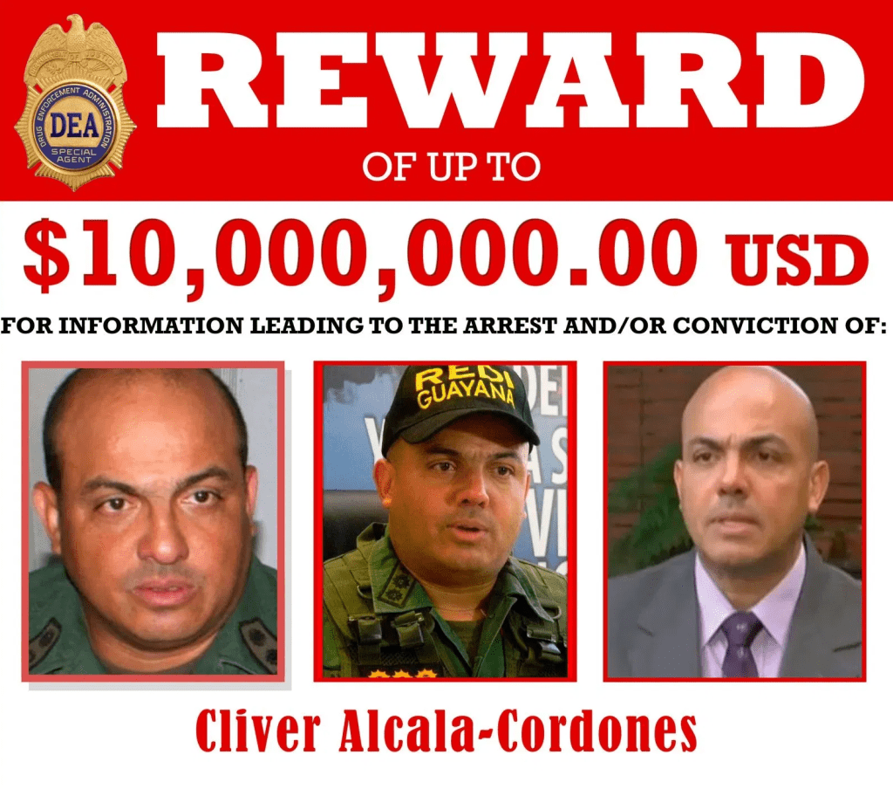

A wanted poster for Clíver Alcalá Cordones was published by the U.S. Drug Enforcement Administration on March 26, 2020.
Email records shared with Goudreau’s legal team show Horn used his White House email to contact State Department employee Hillary Batjer Johnson about Alcalá. Johnson connected Horn with another State Department employee, Carrie Filipetti, and asked Filipetti if she could direct Horn “to the appropriate folks at State and DOJ.”
Further correspondence reviewed by The Grayzone shows Schiller was also contacted by Goudreau regarding “an emergent situation” with “American lives at stake.” Schiller did not respond.
Goudreau’s outreach on Alcalá’s behalf proved fruitless. On March 27, Alcalá surrendered to Colombian authorities. Soon after, Horn told Goudreau that the former Venezuelan major general was being extradited to the United States. The man Goudreau knew as “Caesar,” and whom he considered “the absolute strongest voice against Maduro,” had been ruthlessly sidelined.
Caught in the crossfire between a power-hungry opposition which sought to prevent another strongman from seizing the presidency, and a US government which never forgave his full-throated endorsement of Chavismo, Alcalá ultimately pled guilty to providing material support to the left-wing FARC guerrillas in Colombia, and was sentenced to nearly 22 years in US prison.
In Venezuela, the arrest dealt a blow to Goudreau’s credibility among his crew of former soldiers, who’d come to view Alcalá as their leader. It also threw a wrench into his plans to recruit other Venezuelan military leaders.
“After Barr and Pompeo had Alcalá arrested, the Venezuelan military saw this as the ultimate betrayal,” Goudreau reflected to The Grayzone. “So they began to draw closer to Maduro.”

Exposed on Venezuelan TV
Following Alcalá’s arrest, Venezuelan authorities continued to dismantle the operation, homing in on Goudreau as its ringleader. On a March 28 broadcast of his nationally broadcast variety show, “Con El Mazo Dando,” Constituent Assembly President Diosdado Cabello exposed Operation Gideon, warning that a number of “American mercenaries” had been contracted to capture or eliminate high-ranking Venezuelan officials. Cabello displayed photos and video footage showing Goudreau working security at the Trump rally, which he said suggested the scheme was linked directly to the White House.
Goudreau characterizes this as the period when he decided to abort Operation Gideon and extract his team from Colombia by boat. But once again, the plot went awry.
Having previously positioned some of the resources for the Venezuela operation in Jamaica, Goudreau says he made a stop there to collect them on his way to Colombia.
Citing anonymous sources, numerous US media outlets reported that a representative of the CIA approached Goudreau during his stopover in Jamaica and warned him not to go through with the plan. Goudreau denies such a direct interaction with any CIA employee or asset ever occurred.
Instead, Goudreau said, he struck out for Colombia, and made it dozens of miles out to sea before a belt on his boat’s engine broke, leaving him stranded.
“This is the part that’s really strange. I mean, these belts were new, and the belt breaks, when they should have been good for a lot longer,” Goudreau said.
Goudreau remained stuck at sea for nearly three days before a Chinese tanker picked them up and carried them back to the Gulf Coast of the United States. Back in the United States, with his boat no longer running and flights limited by newly-announced COVID-19 restrictions, Goudreau weighed his dwindling options.

“need State Department approval to send guns and ammo”
Fearing left-wing Colombian guerrillas would discover his forces if they stayed in their training camps, Goudreau said he reluctantly chose to proceed with his operation, hoping his assault force could still successfully link up with allies in Venezuela. He acknowledged the plan was risky, and said he hated the idea of sending his team into harm’s way while he wasn’t there with them, but claims it was the least in a series of bad options.
“I make it a fucking habit of always going in the door first. I go first. Because I want people to follow me. I don’t fucking lead from the rear, man. I have to lead from the front. This is why Venezuela was heartbreaking to me, because my boat broke and I didn’t get to lead them,” Goudreau said.
Two days before Operation Gideon’s launch, another setback occurred when the Associated Press (AP) published the details of a military plan to overthrow Maduro. Citing several anonymous sources, the AP described some of Goudreau’s interactions with the Venezuelan opposition community and sketched out what Goudreau said was an old version of his coup plan.
The May 1, 2020, AP article described an operation in which an assault force would travel overland by convoy, fighting from the Colombia-Venezuela border all the way to Caracas. Toledo, in his FBI interview, confirmed that he was aware of a version of Goudreau’s attack plan that would involve his forces crossing over from Colombia to the northern coastal Venezuelan state of Zulia, and continuing east toward Caracas.

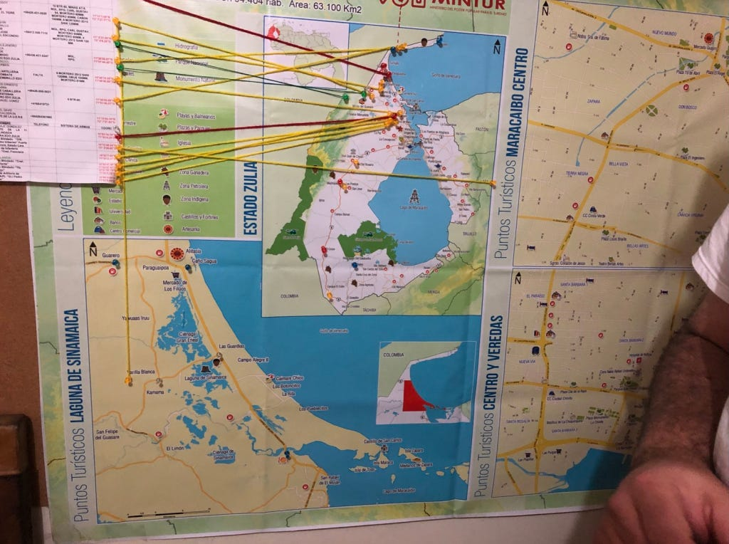

A photo taken on June 16, 2019 shows maps identifying military targets for Operation Gideon on display at the group’s Colombian headquarters. (Photo courtesy of Jordan Goudreau)
Goudreau acknowledged that the AP article had undermined the element of surprise for his operation, but said he calculated that the land-based assault it described was different enough from the true plan of a sea-borne raid that his assault force could still catch the Venezuelans off guard.
The same day the AP published the article, Goudreau said the first of his assault force’s two boats launched from Colombia’s coastline, carrying 11 people. The next day, Denman and Berry departed on a larger boat with the rest of the assault force.
As he monitored the plan’s progress from a distance on May 3, Goudreau texted Horn, “I have 500 people in Colombia standing by but… need State Department approval to send guns and ammo.”
Horn, who by this point was working as a senior advisor at the Office of the Director of National Intelligence, replied, “Ok, let me work on it and see what I can do. I’ll have an update for you tomorrow.”
Not content to wait for Horn’s help, Goudreau took to Twitter, writing, “Strikeforce incursion into Venezuela. 60 Venezuelan, 2 American ex Green Beret” and tagged Trump’s Twitter account. This, Goudreau says, was a cry for help.
By the afternoon of May 3, Goudreau and former Venezuelan National Guard Cpt. Javier Nieto Quintero had filmed a video in which they claimed their forces were fighting in the south, west, and east of Venezuela. This, he says, was a deliberate falsehood intended to misdirect Maduro’s forces and buy his team some time to escape.

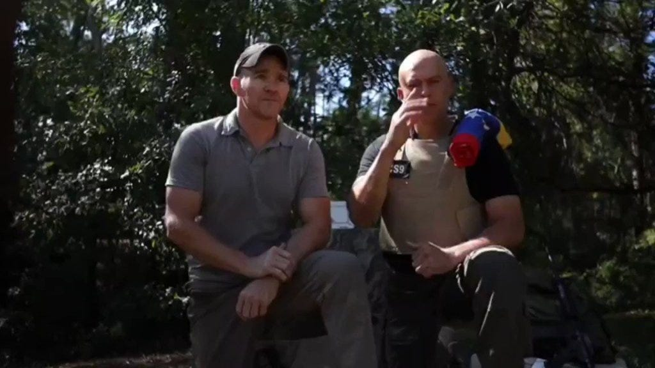
Goudreau and Quintero announce Operation Gideon on May 3, 2020.
Though he was himself safely removed from the action, Goudreau’s public statements in the middle of his coup operation represented his most desperate attempts to save his team. Both efforts would fail, and would become the punchline of a seemingly endless stream of jokes about the bungled operation.
By May 5, 2020, at least six of Goudreau’s assault force members had been killed in a gun battle. Denman, Berry, and dozens more had been captured. News footage showed the Green Beret veterans being frogmarched off to prison by their captors.

A contractually deniable coup
As Goudreau’s plan fell apart, Trump and other members of his administration quickly denied Washington played a role in the coup plot.
“There was no U.S. government direct involvement in this operation. If we had been involved, it would have gone differently,” Pompeo told reporters on May 6. “As for who bankrolled it, we’re not prepared to share any more information about what we know took place. We’ll unpack that at an appropriate time.”
Goudreau maintains he had Trump’s blessing to put together his operation, but was undone by disparate elements in the US government and the Venezuelan opposition community, who found themselves at cross purposes: “I had a meeting with several powerful people in Trump’s inner circle. After that contract was signed, a few hours later I have this meeting in the Trump hotel. And then a few hours after that, [Trump and Guaidó] have a meeting in the White House.”
Further, Goudreau has claimed he avoided closer interactions with Trump and worked through intermediaries to preserve a degree of plausible deniability for the president.
“If I met with Donald Trump and got a certificate and was able to show some kind of contract or, you know, some written authorization or something, that kind of defeats the purpose behind the intent,” he said.
Goudreau said he expected the U.S. government to disavow him if he failed. But he had not anticipated it would prosecute him, forcing him to draw back the cloak of secrecy he had built into Operation Gideon.
Deniability was explicitly incorporated into Goudreau’s contract with Rendón. The agreement stated Guaidó could “maintain deniability and be absolved from all knowledge and fault by all parties” for the operation. And indeed, Guaidó has.

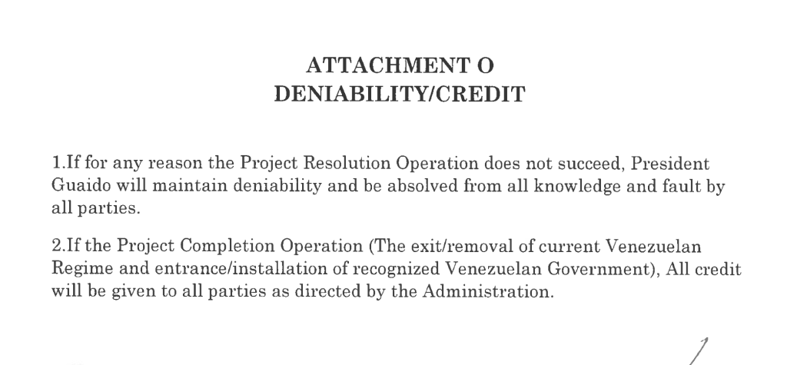

After distancing himself from Goudreau’s operation, Guaidó accepted the resignation of Rendón and another individual involved in drafting that contract, after Rendón acknowledged his role in discussions with Goudreau.
In October 2020, Goudreau filed a lawsuit against Rendón for breach of contract, alleging Guaidó’s team failed to pay the remaining $1.45 million required to initiate the Venezuela coup plot. Rendón’s legal team filed a motion to dismiss the case, but a judge denied their motion in a February 2025 order.
Around the time Goudreau stepped forward with his civil complaint, Beardsley began working with Department of Veterans Affairs employees Curtis Cashour and Peter Kasperowicz to draft a statement he could share if asked about his connection to Goudreau’s Venezuela coup plot. Beardsley and his government colleagues prepared multiple drafts of the statement, in which Beardsley would indicate that his interactions with Goudreau were unrelated to his government work. The drafts stated Goudreau first approached Beardsley to discuss humanitarian efforts for refugees in Colombia, and that when Goudreau brought up Venezuela, Beardsley insisted the U.S. government could not support any effort in that country that violates US law.
The drafts further state Beardsley invited Goudreau to discuss humanitarian work, but that Goudreau never followed up on that offer. Several of the drafts conclude with Beardsley stating, “Everything I know about his activities in Venezuela I learned from reading the papers.”
Juan Cruz, the former CIA director for Latin America, provided commentary about Goudreau’s failed Venezuela operation for an October 2020 interview with Business Insider. Reached through his current employer, Washington DC-based think tank CSIS, Cruz refused The Grayzone’s request for an interview.
In his FBI interview, Schiller acknowledged he knew Horn well and had helped him and Beardsley find jobs in the Trump administration. However, Schiller said he found it strange to learn Horn also had contact with Goudreau in the lead-up to Operation Gideon.
Horn, for his part, told the FBI he was surprised to learn Schiller had also been discussing the plan with Goudreau.
Goudreau dismisses their pleas of ignorance, noting that the only possible motive any of the Trump affiliates could have had for maintaining communication with him was his involvement in the planned military operation in Venezuela: “There is absolutely no reason for Drew Horn to be talking to me or Jason Whitley to be talking to outside of this.”
In January 2021, Horn, Schiller, and Sorial co-founded a company called GreenMet, which is currently pursuing partnerships in Greenland’s critical mineral sector. The company’s website lists Horn as the CEO, but no longer lists Schiller and Sorial among its staff. A profile on GreenMet published by Bloomberg in 2025 described Horn as having “emerged as a key middleman amid President Donald Trump’s campaign to harness the natural resources of the world’s largest island for America’s benefit.”
In 2024, Schiller and Sorial formed Javelin Advisors, a government relations and consulting firm. Lobbying disclosures indicate the company has registered to lobby for “executive relief” on behalf of Fred Daibes, who pleaded guilty in September 2024 to making false statements on a $1.8 million bank loan document. Lobbying records indicate Javelin Advisors registered as lobbyists working for Daibes in January, and Daibes has since paid the company $1 million for their services.
Last month, Javelin Advisors registered as lobbyists on behalf of Greg Lindberg, seeking an “executive pardon” for their client. Lindberg pleaded guilty in November in connection with a $2 billion fraud and money laundering scheme.
Javelin Advisors has also registered as a lobbyist on behalf of a company called Capstone USA Advisory Group. The stated purpose of this lobbying effort is “U.S. Government relations and related outreach to help promote potential U.S. Government-sponsored reconstruction initiatives in Ukraine.”
The Biden administration won Denman and Berry’s release in a December 2023 prisoner exchange.

Goudreau goes missing
Federal prosecutors indicted Goudreau and Alvarez in July 2024, charging them in connection with the shipment of weapons and military gear Colombian authorities seized in the spring of 2020.
The indictment asserts Goudreau purchased 61 kits for assembling AR-style firearms, including incomplete lower receivers that would have to be machined to be turned into firearms.
Prosecutors allege Goudreau ordered the weapons shipped sometime between December 2019 and March 23, 2020, though they don’t say exactly when or how the firearms reached Colombia.
In addition to the 26 AR-style firearms, Colombian authorities also reported seizing eight firearm suppressors listed as “solvent traps,” dozens more aiming lasers and weapons sights, and a single night vision monocle sight. Some of these items provide the basis for other export violations charges.
On Jan. 10, Goudreau and Alvarez both filed a notice of public authority defense, indicating they’d argue that the criminal charges stemmed from actions they took at the behest of the U.S. government.
During his own criminal case, Alcalá attempted to argue that the CIA knew he was working against Maduro. Alcalá sought access to classified records that could prove his claims, but the CIA invoked a state secrets privilege, and a federal judge rejected his request for access to the records.
Goudreau and Alvarez have had some success compelling the U.S. government to release records that could demonstrate its knowledge and support for Goudreau’s failed operation, but they haven’t received all the records they’re seeking.
Goudreau told The Grayzone that he wished federal prosecutors would take his arms trafficking case to trial, because it would allow his legal team to seek classified US intelligence documents which were previously unavailable through discovery. But at the moment when a trial appeared inevitable, he took evasive action.
Following his release from custody in 2024, Goudreau moved in with Jen Gatien, an acclaimed documentarian who produced the film “Men of War” about Operation Gideon. After pledging her $2 million Manhattan home as collateral for Goudreau’s bond, the pair fell into an ugly dispute in which Gatien reportedly accused Goudreau of failing to transfer his “significant cryptocurrency holdings” to her after she helped secure his release. As she sought to be released from her role as bond guarantor, Goudreau texted her, “I’m not going back to prison.”
On October 31, 2025, Goudreau was ordered to attend a hearing to determine whether he had violated the conditions of his pre-trial release. He failed to appear in court, leaving his ankle bracelet behind at a Tampa, Florida-area center where he was undergoing equine-assisted therapy. This prompted a federal judge to issue a warrant for his arrest. The Grayzone has been unable to contact him since then, and his whereabouts remain unknown.
Before his disappearance, Goudreau told The Grayzone that the case against him “was really a cover up.” He said the myriad connections between the various players involved suggested foul play.
“My prosecution was initiated from the national security component of the DoJ. That component is run by a guy named John Eisenberg,” he explained. “Eisenberg was placed there initially by [ex-General] Michael Flynn. He was in the White House at the time Keith Schiller was in the White House. So these individuals were working together. Where I come from, that’s a conflict of interest.”
Kraft did not respond to a request for comment for this article.
Sainz, Schiller, Beardsley, Betancourt, and Toledo did not respond to requests for comment.
Several days before he went off the radar, Goudreau reflected to The Grayzone’s Max Blumenthal: “I do not think a military coup is possible now. If it was, it would’ve already happened. Everything you see that the US is doing, including destroying fishing boats, is rattling. Only an invasion is possible.”

